Operations Implemented under the Gas Act 2000

Annual Report
2018/19

REPORT OF THE DIRECTOR OF GAS SAFETY
This is the annual report of the Director of Gas Safety pursuant to the Gas Act 2000. It describes the operations of the Director’s office for the financial year 2018/19 as required by Section 16 of the Act.
The Director of Gas Safety is a statutory appointment established by Section 9 of the Gas Act 2000. Mr Dale Webster and Mr Andrew Goldsworthy held this position for the period covered in this report.
The Gas Act 2000 requires the Director of Gas Safety to deliver to the Minister a report on the Director's operations during the previous financial year. The Minister must cause a copy of each report to be laid before both Houses of Parliament.
A/Director of Gas Safety: Andrew Goldsworthy
Office: Consumer, Building and Occupational Services
Office Address: 30 Gordon Hills Road, Rosny Park 7018
Postal Address: Director of Gas Safety
PO Box 56
Rosny Park 7018
Telephone: 1300 654 499
Office hours: 9:00am to 5:00pm, Monday to Friday
(Except public holidays)
Website: www.cbos.tas.gov.au
Email: cbos.info@justice.tas.gov.au

Preface
This report covers the Director of Gas Safety’s operations under the Gas Act 2000 (the Act) as it was in force for the 2018/19 financial year.
Section 4 of the Act states that the objectives of the Act are:
- to facilitate the development of a gas supply industry in Tasmania; and
- to promote efficiency and competition in the gas supply industry; and
- to promote the establishment and maintenance of a safe and efficient system of gas distribution and supply; and
- to establish and enforce proper standards of safety, reliability and quality in the gas supply industry; and
- to establish and enforce proper safety and technical standards for gas installations and appliances; and
- to protect the interests of consumers of gas.
The Director of Gas Safety is appointed in accordance with Section 9 of the Act.
Section 10 of the Act states that the Director of Gas Safety has the following functions:
- the monitoring and regulation of safety and technical standards in the gas supply industry;
- the monitoring and regulation of safety and technical standards with respect to gas installations and gas appliances.
The Director of Gas Safety, in administrating the Act, participates in a range of activities in cooperation with the gas industry and other Government agencies. This includes gas entity licensing functions and gas emergency management vested with the Regulator and Minister for Energy, Department of State Growth respectively.
The Director’s actions in relation to these functions are dealt within this report.

Table of Contents
REPORT OF THE DIRECTOR OF GAS SAFETY 2
Preface 3
Office of the Director of Gas Safety 6
Vision 8
SECTION 1: Gas Distribution 9
1.1 Natural Gas Rollout 9
1.2 Network Incident and Accident Reporting 9
1.3 Gas Distribution Entity Safety and Operating Plan 10
1.4 Gas Distribution Standards 10
1.5 Distribution Network Equipment and Integrity Management 11
1.6 Dial Before You Dig 11
1.7 Isolated Gas Networks 11
1.8 Gas Distribution Network Life Cycle Auditing 12
Table 2: Director’s Gas Network - Life Cycle Administration and Safety Program 12
1.9 Annual Distribution Gas Entity (Enwave) Performance Report 13
Table 3: Gas Distributors Operational Performance 2018/19 (extracted from the Enwave annual reporting data to the Director of Gas Safety 2018/19) 13
SECTION 2: Gas Retailing 14
2.1 Gas Retailer Emergency Gas Curtailment Planning 14
SECTION 3: Gas Suppliers, Storage Systems and Conditioning 15
3.1 Liquefied Natural Gas (LNG) 15
3.2 LP Gas (LPG) 15
3.3 Compressed Natural Gas (CNG) 16
3.4 Biogas and Hydrogen 16
SECTION 4: Gas Installations and Appliances 16
4.1 Notification and Certification 17
4.2 Complex Gas Installation Design Acceptance 17
4.3 Prescribed Standard Gas Installation Acceptance 18
4.4 Type B Gas Appliance Acceptance 19
Table 4: Tasmanian approved gas appliance external authorities 21
4.6 Type A Gas Appliance Acceptance - Individual Appliance Certification Schemes 21
4.7 Prohibition of Sale, Product Withdrawal and Recall of Gas Appliances and Components 22
Table 5: Tasmanian gas appliance and components prohibition of sale, product withdrawal, recall, and safety alert 22
4.8 Major Events 23
4.9 Internet Sale of Gas Appliances 24
4.10 Carbon Monoxide 24
4.11 Gas Installation and Appliance Incidents 24
SECTION 5: Office of the Director of Gas Safety Programs/Achievements 25
5.1 Regional Delivery of Programs 28
Table 7: Summary of Achievements 28
5.2 Inspection Program 31
5.3 Technical Standards Development 33
Table 8: Technical Standards Development and Implementation 2018/19 33
5.4 Vehicle Gas Fitting and Stationary Engines 33
5.5 Gas Committees and Associations 34
Table 9: Participation in committees and organisations 34
5.6 Policy Development and Legislation 34
Table 10: Communication products 35
Gas safety and technical publications 36
Gas safety and technical publications 36
Expos and other public events 36
Social media (Facebook) 36
5.8 Gas Supply Management 36
5.9 Emergency Incident Coordination 37
SECTION 6: Inter-government Industry Administration 37
SECTION 7: Conclusion 37
APPENDIX 1: Glossary and Abbreviations 38

Office of the Director of Gas Safety
The Director of Gas Safety is supported by the Office of the Director of Gas Safety, Gas Standards and Safety (GSS).
The GSS unit is managed by the Manager Gas Safety, Mr Andrew Ayton, who is delegated the functions of the Director.
The GSS unit operates within the structure of Consumer, Building and Occupational Services (CBOS) branch along with Building Standards, Electrical Standards, Compliance and Dispute Resolution, Consumer Affairs, Corporate Affairs, Rental Services and Occupational Licensing and Accreditation.
This structure enables resource and knowledge sharing which results in efficiencies between technical and non-technical units for energy safety administration. GSS values along with the implementation of the CBOS Strategic Plan provides for continual improvement and assurances that programs are providing efficient and effective public value.
In line with the CBOS Strategic Plan GSS are continually investigating methods to increase public safety program effectiveness. The capture of gas fitting work inspection data and a review and revision of GSS enforcement practises allows for the implementation of tailored intervention programs aimed at decreasing community’s exposure to harm through a reduction in gas-fitting non-conformances and resultant incidents. This is complimented by the CBOS web site and use of social media to provide convenient availability to gas safety information.
The Office of the Director of Gas Safety comprises five Authorised Officers and one Administrative Officer, with additional administrative support from CBOS administration and records staff.
Administrative and industry performance functions are centralised in Launceston, with the capability for gas industry safety and compliance programs in each region. Specialist policy functions are resourced from appliance installation and infrastructure Gas Safety Specialists in conjunction with the CBOS Policy, Projects and Communications team.
Availability of resources during the reporting period has prevented full support of regionally based technical and inspection programs and the capability for all downstream installations and infrastructure inspection services, including individual industrial and commercial appliance (type B appliance) technical programs. Recognised training, mentoring and recruitment are expected to assist achievement of core risk reduction programs.
The GSS unit operational structure and activities are shown in Figure 1.
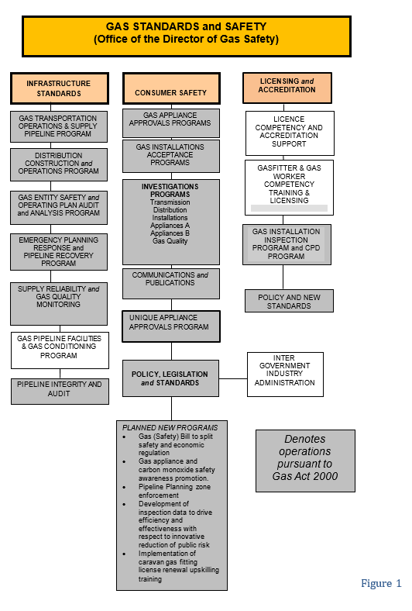

Vision
Consistent with the guiding aim of the Department of Justice to provide ‘A safe, fair and just Tasmania’, and in accordance with the role of the Director of Gas Safety, GSS strives to provide leadership and effective governance in respect to gas infrastructure, downstream installation safety and technical standards. GSS achieves this by ensuring the evolving natural gas, compressed liquefied natural gas, biogas, hydrogen and LP Gas industries achieve levels of excellence in construction, operations, reliable supply, acceptable public safety and energy efficiency.
The Director of Gas Safety will:
- ensure that gas infrastructure operations achieve high standards of safety, reliability and control inherent risks;
- provide advice to the gas industry to achieve best practice in gas safety;
- develop communication products and promote consumer understanding of gas safety through education and communication;
- work with industry stakeholders to ensure the efficient and safe evolution of gas technology and work standards for Tasmanian consumers;
- in conjunction with national jurisdictions, work to achieve desired levels of national harmonisation in the regulation of gas safety technical standards; and
- work to achieve contemporary program delivery models to enhance efficient operations.

We achieve our vision through the following values, expected from our team at all times.
Excellence: We strive for quality and excellence in our functions.
Respect: We treat all stakeholders and staff with respect.
Accountability: We take responsibility for our actions and decisions.
Integrity: We make decisions on merit, based on facts, logic and due process.
Commitment: We work cooperatively, mentor and support other team members to enhance development of the gas industry in Tasmania.
Cooperation: We work cooperatively, inclusively and are open in our dealings.
Creativity: We seek to solve problems creatively within the boundaries of prescriptive standards and codes.

SECTION 1: Gas Distribution
Gas networks continue to provide a reliable supply of natural gas to an increasing number of consumers through Natural Gas Distribution Facilities operated under licence by Enwave Australia (Enwave); Tas Gas Networks changed their trading name to Enwave during the reporting period however operationally there has not been any variation.
Effective planning for natural gas supply/quality and the successful response to incidents by gas entities, Department of State Growth, major consumers and the Director’s office has prevented any major widespread interruption to Tasmanian natural gas supply.
It is pleasing that a continued emphasis on investigating the vast majority of near miss third party activities has maintained a low rate of incidents. It is predicted that this approach, along with tailoring educational programs following exploration of the human factors involved will continue to reduce the high-risk gas release incidents.
Mechanical fault at a pressure reduction station resulted in the loss of gas supply to 101 customers connected to the Longford network. Oversight of subsequent remedial works, investigations and auditing conducted by the Director’s office meant gas was restored without incident, structural integrity of the networks was not compromised and the likelihood of a reoccurrence reduced.
The Director continues to maintain regular meetings with Enwave to facilitate the open exchange on network operational and regulatory matters. These meetings have been held quarterly and have been of considerable benefit to both Enwave and GSS.

Natural Gas Rollout
Natural gas network expansion and construction has been limited to an additional 4.76 kilometres. Natural gas network/s augmentation has been predominantly associated with major developments, with smaller additions to facilitate the connection of natural gas consumers when deemed commercially viable by Enwave.
The Director is not aware of any intended major network extensions.

Network Incident and Accident Reporting
Incident and accident reporting by the distributor has been ongoing. Incident data is collated and assessed for trends to determine both the root cause and required risk controls.
Whilst data shows a slight increase in the number of incidents for this reporting period. (Refer Figure 2), the number of high risk uncontrolled releases of gas have decreased. Considering ongoing proactive monitoring of near miss third party encroachments, application of lead and lag indicators and fresh analyses to determine the human factor elements causing such risk taking behaviour, the Director is confident that increasingly targeted prevention programs will continue to result in positive safety outcomes into the future.
No injuries to employees or the public have resulted from any incidents, and gas network metering and isolation design has been compliant and acceptable.

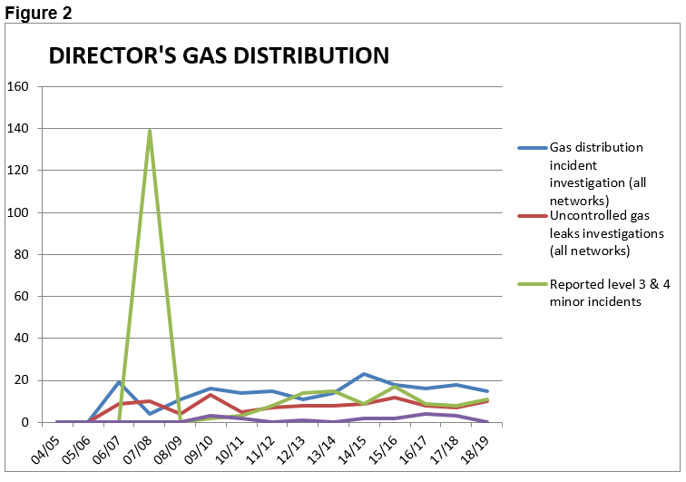

Gas Distribution Entity Safety and Operating Plan
Following a comprehensive review by GSS, the Director approved an amended gas entity safety and operating plan during the 2016/17 reporting period. The Director’s safety and operating plan approval is valid for 5 years unless a revised plan is required due to significant change to gas entity safety management systems or altered infrastructure hazards results in increased levels of risk.
The Director continues to measure safety, reliability and structural integrity performance against this current independently certified and accepted safety and operating plan for the gas entity’s natural gas networks.

Gas Distribution Standards
Gas Entity Tier 2 and 3 design and operation policy and procedures are living documents that are amended by the gas entity due to technological advancements and as risks are identified through formal safety assessments (FSA). Current gas entity standards are consistent with existing activities and compliance requirements. There were no significant amendments to distribution standards during the reporting period. With a focus on continual improvement, the Director receives and reviews periodic standard amendments and when needed will require independent certification to ensure conformity.
High pressure steel distribution pipeline integrity is achieved by gas entities implementing a systematic safety management approach to design, construction, operation and maintenance activities in conjunction with sound engineering principles prescribed in Australian standards. To ensure continued pipeline operational integrity the Director is expecting a full review of these safety management systems, including an independent audit conducted by a person approved by the Director, in the latter half of 2019.

Distribution Network Equipment and Integrity Management
Due to limited network extensions the regulatory focus remains on assessment and validation of infrastructure integrity and operational management. To maintain the structural integrity of assets the gas entity is required to review all factors that have a bearing on the pipeline every 5 years. Reviews include remaining life, location class, safety management study and pipeline coating assessments involving cathodic protection reviews, direct current gradient surveys, pipeline dig up surveys, and pipe wall integrity assessments using intelligent pipeline integrity gauge/s (PIG).
This program uses maintenance records, physical characteristics and operating history of the networks to predict the integrity of a given network. The Director received and reviewed Hobart pigging, joint coating, and leakage detection surveys during the reporting period.
Further gas leaks identified on the East Devonport 1000 kPa polyethylene network were found to be again a result of construction faults and local stresses. Leakage surveys, pressure tests and pipe joint bar holing continue to be conducted until confident that similar risk factors have been excluded.
Tasmania’s population growth affects encroachment of urban development on existing pipelines. This is becoming a major issue in Tasmania and across Australia. As a result gas entities and the Director have commenced engagement with the Tasmanian Planning Commission and permit authorities, including distribution of dedicated educational material.
To ensure public are not exposed to unacceptable risk GSS have conducted reactive audits across gas entity permit to works systems, network repairs and staff emergency response competency and training. It is the Director’s intention to develop and implement a proactive audit program in the third quarter of 2019 in line with the previously released Tasmanian Gas Industry Audit Policy.

Dial Before You Dig
The Director strongly encourages the use of the Dial Before You Dig phone and internet service by all infrastructure owners and contractors undertaking civil excavation in the proximity of gas infrastructure.
Enforcement action, regular presentations and guidance information provided to Tasmanian trades and affiliated professionals endeavours to drive the use of the Dial Before You Dig system.
The protection of buried gas infrastructure has been further enhanced with a Memorandum of Understanding (MoU) being reached between Enwave and TasWater. The MoU agrees on certain protocols that both companies will follow to work collaboratively together for the security of vital infrastructure.

Isolated Gas Networks
No new isolated gas networks were constructed in 2018/19.
The Director receives annual audits for the single inset network at Glenara Lakes, Launceston to ensure the satisfactory implementation of the approved safety and operating plan. The third of these audits was received by GSS in the first quarter of 2019. Whilst the audit highlighted the integrity of network was sufficient to provide a safe gas supply it highlighted that leakage surveys, emergency response equipment inventory and emergency response exercise are required to ensure ongoing network reliability. The Director of Gas Safety is actively monitoring the close out of these audit actions.

Gas Distribution Network Life Cycle Auditing
GSS continues to implement an audit program in accordance with its gas infrastructure audit policy. The policy provides for a systematic, structured and consistent auditing approach across all gas infrastructure, gas entities and licensees. The policy also outlines GSS audit principles and the underlying strategy adopted to ensure gas infrastructure is managed satisfactorily.
In line with the audit policy, the Director’s natural gas network and high-pressure distribution pipelines integrity management audits continued to be a priority during the reporting period included pipeline leakage identification and repair, live pipeline pin brazing and adequacy of first responders emergency response training.

Table 2: Director’s Gas Network - Life Cycle Administration and Safety Program
Formal Safety Instrument | Administrative Program | Purpose
Gas Entity – Pipeline Integrity management plan | Initial document and implementation review | Pipeline system design, construction, operation and maintenance activities, in conjunction with the application of sound engineering principles with due regard to safety
Gas Entity Pipeline maximum operating pressure review | 5 year review | Technical compliance and public safety
Steel pipeline integrity plan review | Direct current and ground variance for direct assessment | Detect and monitor deterioration of pipeline protective coating condition
 | Inline inspection of pipelines | Detect and monitor internal condition of pipe and its capability to operate at MAOP
 | Pipeline quality gas review | Detect out of specification product, frequency and effects analysis
 | Finalisation of electrical installations in hazardous areas audit | Maintain safe electrical installations at meter stations to ensure acceptable network reliability and public safety
Gas Entity - Full Safety Assessments of gas networks | Review of infrastructure hazards and currency of protective systems | Maintenance of public safety and pipeline management from encroachment
Gas Entity - Safety management systems | Review currency with operations and construction | Maintain acceptable network reliability and public safety
Gas Entity - Network design certifiers acceptance | Approval of Independent Design Certification | Technical compliance of new networks designs
Gas Entity Operations Auditing | Audit implementation of acceptance safety and operating plans | Maintenance of public safety through acceptable pipeline operations

Annual Distribution Gas Entity (Enwave) Performance Report
In line with contemporary public safety strategies, nationally consistent reporting criteria provide lead safety and reliability indicators.
Lag (near miss) and lead indictors are collated and reviewed across reporting periods to determine the ongoing adequacy and effectiveness of risk mitigation actions including safety critical operations, maintenance activities, hazard identification, training, network integrity and emergency preparedness.

Table 3: Gas Distributors Operational Performance 2018/19 (extracted from the Enwave annual reporting data to the Director of Gas Safety 2018/19)
Statistics | Polyethylene Mains |  | Steel Mains
 | 500 kPa | 1000kpa | 5.0 MPa
Length of distribution network (kilometres) | 736.98 | 55.05 | 45.87
Public third party reported gas leaks | 215 | 0 | 0
Gas escapes on mains not caused by third parties | 0 | 2 | 0
Kilometres of network subjected to leak survey | 113 | 63 | 45
Leaks detected during surveys | 0 | 2 | 0
Leak repairs as result of surveys | 0 | 2 | 0
Emergency / Incident response
Level 4 incidents | 11
Level 3 incidents | 4
Level 2 or 1 incidents | 0
Emergency response exercises planned | 5
Emergency response exercises completed | 5
Average time to respond to emergency notification | 19 minutes
Longest time to respond to emergency notification | 45 minutes
Dial before you dig enquiries | 14,493
Third party interference where Dial Before You Dig enquiries were performed | 7
Operational performance
Scheduled audits | 319
Non-conformance identified | 7
Non-conformance not corrected in scheduled time | 0
Gas quality tests | 4
Gas quality excursions (including odorant) | 0
Pressure/ temperature excursions | 1
Cathodic protection system surveys conducted | 2
Unsatisfactory CP system test results | 0

SECTION 2: Gas Retailing
Retailing of natural gas to industrial, commercial and domestic retail consumers is undertaken by licensed gas entities Aurora Energy Pty Ltd and Tas Gas Retail Pty Ltd. Consumer connections to the natural gas network increased by 3% this financial year.
The Regulator licenced a third gas retailer during the reporting period, Weston Energy. Weston Energy reportedly operate a new and innovative business model, activities limited to purchasing gas from the mainland gas markets and arranging client’s transportation. The Director’s office is working with the retailer on the development and approval of their Safety and Operating Plan detailing how they intend to manage the safety of regulated activities.

Gas Retailer Emergency Gas Curtailment Planning
Gas Entity Safety and Operating Plans are reviewed on a five yearly cycle unless major changes to operational risk values require a review sooner, as prescribed. As a result the Director assessed and accepted a revised Tas Gas Retail Pty Ltd plan including independent audit by a person approved by the Director. Gas entity plans continue to be aligned with industry agreed gas quality and emergency gas supply coordination provisions.
The Director remains in the role of the Tasmanian Jurisdictional Contact Officer (JCO) under the National Gas Emergency Response Advisory Committee (NGERAC). NGERAC was not convened during the reporting period however the Director was involved in weekly national teleconference over the summer period to discuss potential gas production/storage, weather and gas fired power generation matters to establish any potential threat to Tasmanian natural gas supplies.

SECTION 3: Gas Suppliers, Storage Systems and Conditioning
Independent certification of design, installation, testing and mechanical completion procedures for gas storage facilities CNG, LNG and LP Gas is required.
Co-operation with all gas suppliers continues to result in improved gas safety standards and compliance.

Liquefied Natural Gas (LNG)
Supply of LNG to industrial consumers is an alternate energy option for large and small consumers isolated from the NG transmission system. This has provided economic energy advantages for a number of consumers.
The current trend of underutilisation of LNG as a transport fuel may change if proposed LNG propelled ships source LNG from Tasmania. Such an outcome will most likely result in the expansion of the current LNG production facility.
Existing gas storage safety management systems are being implemented effectively in this sector of the fuel gas industry. This includes the review of LNG suppliers’ implementation of gas safety management plans for gas conditioning and storage facilities, and major installations. This has included ongoing review and consultation in respect to the BOC’s Westbury LNG gas pipeline facility safety case.
GSS continues to audit the safe management of BOC’s Westbury LNG gas pipeline facility in consultation with the Major Hazard Facility (MHF) branch of WorkSafe Tasmania. The audit undertaken this reporting period included an extensive review of safety management system performance including maintenance management systems, close out of targeted internal audit corrective actions, engineering management of change, safety critical instrument functional testing.

LP Gas (LPG)
LPG connections remain high in areas not serviced by NG networks.
Public safety for the LPG storage, supply, installation, marine vessel and vehicle gas conversion industries, has been maintained as part of the Director’s administrative role. This involves ongoing coordination and consultation between the Director, WorkSafe Tasmania and LPG suppliers.
Meetings held with all LP gas suppliers has increased LPG supply location compliance and safety. The subsequent review of delivery driver training, compliance checklists, and non-conformance reporting has resulted in a major increase in customers requesting gas installation safety and compliance assessments.
Incident causation data has compelled an investigation into the replacement of the current POL connection used to connect gas cylinders and portable appliances. The Director and GTRC through consultation with industry expects the roll out of a safer QCC valve in the leisure gas portion of the industry by mid to late 2020. It is expected that the replacement valve will provide measurable public value as a result of incorporated leakage prevention features.

Compressed Natural Gas (CNG)
The CNG conditioning and storage process is managed under the Director’s gas safety management plan and gas storage approvals system.
The Self Point CNG facility owned and operated by natural gas distributor Enwave remains the solitary CNG dispenser in Tasmania. Further expansion of this fuel’s availability to industrial and commercial fleets has not yet eventuated.
Dependent on the success and viability of current Victorian gas infrastructure developments using CNG storage as a means of gas supply to isolated natural gas distribution networks, the Director anticipates the development of similar systems to supply isolated industrial and commercial precincts.

Biogas and Hydrogen
The search for alternative energy is driving new projects by commercial and industrial consumers to offset escalating energy costs and meet environmental expectations; methane being 50 times more harmful than carbon dioxide as greenhouse gas.
The expectation is that Biogas (dairies, rural husbandry), municipal and industrial waste gas capture and combustion for energy generation will increase due to the increased frequency of enquires received by the Director’s Office. This includes the development of electricity generation by a landfill gas power generator at Copping, discussions with prospective importers of domestic scale food and human waste biogas digesters and TasWater’s continual upgrade and use of biogas resources at waste water sites.
Excitingly, considerable research is being pursued in the development of a hydrogen economy. Hydrogen offers a new, sustainable energy storage future including transportation. This program is not without its challenges, associated with the safety risks of hydrogen storage, transport and utilisation, and the need to develop appropriate safety standards without unduly restricting hydrogen application. To ensure Tasmania is at the forefront of such standardisation development the Director is a contributing member of the newly formed Hydrogen Technologies Australian Standards Committee and contributing to the COAG Energy Council hydrogen strategy development through working group participants Department of State Growth.

SECTION 4: Gas Installations and Appliances
The installation of new gas service connections continues to maintain a high demand for the Director’s natural gas installations and gas appliance, safety and technical compliance programs.
Applications for new and alterations/additions to existing Type B gas appliance and complex gas installation acceptances have marginally decreased this year. The regulatory focus for these higher risk installations of a greater on site compliance focus, as opposed to desktop design reviews continues to provide a reduction in incidents through increased identification in non-conformances.
Resourcing allocation focused on standard gas installations continues to enhance this program’s productivity in line with industry and public expectations. This has resulted in 735 standard gas installation compliance inspections, 21% of all notified gas fitting work, resulting in substantial reduction in public risk.

Notification and Certification
The Gas Act 2000 installation, notification and certification procedures used by gasfitters to certify work compliance continue to operate effectively.
The Director is undertaking development of further improvements in the installation, notification and connections process by the development of electronic lodgement of applications for acceptance and certificates of compliance. This is a response to industry calls to streamline and upgrade current paper based processes. It is envisaged that the system will allow for integration of occupational licensing and other current data to drive educated risk based compliance programs and scheduling for gas installation safety and technical standards.
Collaboration between Enwave and the Director is expected to identify a minor number of gasfitters who continue not to notify that they have undertaken prescribed work. Given the importance of information provided in gas fitter notifications for the targeted remediation of unsafe gas appliances a number of regulatory actions are available to promote compliance including enforcement protocols in conjunction with the Compliance and Dispute Resolution unit within CBOS for regulatory action pursuant to the Occupational Licensing Act 2005.
Similarly the Director has notified the gas fitting industry that gas fitting work notifications are expected for all gas fitting work as prescribed by the Act. This includes the providing of a Certificate of Compliance and compliance plate for gas fitting work involving gas appliance servicing.

Complex Gas Installation Design Acceptance
A slight decrease in complex gas installation submissions resulted in inspectors completing the design assessment of 181 complex gas installations, primarily at commercial sites. This prescribed function is essentially reactive to industry demand and linked to consumer gas uptake.
Limited increase in network expansion, natural gas supply constraints and price increases, because of markets entering global demand pricing through exports of Liquefied Natural Gas, Continues to affect consumer confidence. However ongoing alterations and additions to existing gas installations illustrates that those that have previously shifted to gas as a source of energy have experienced benefits and are looking to further increase costs and business efficiencies.
A significant resource was allocated to major gas installations including the recently commissioned Ridley fish meal factory at Westbury, electricity generation from bio-gas sourced at the Copping landfill and a safety/integrity review of the Simplot high-pressure consumer piping requiring, remaining life, safety management system and pipeline integrity management plan reviews.
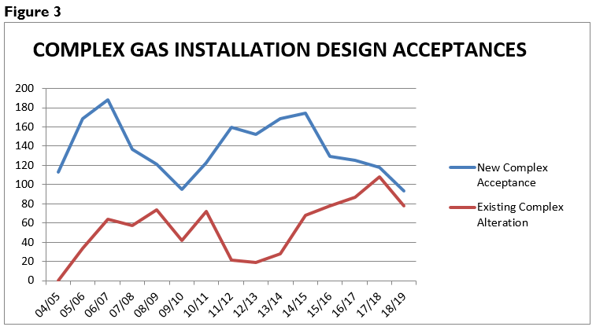
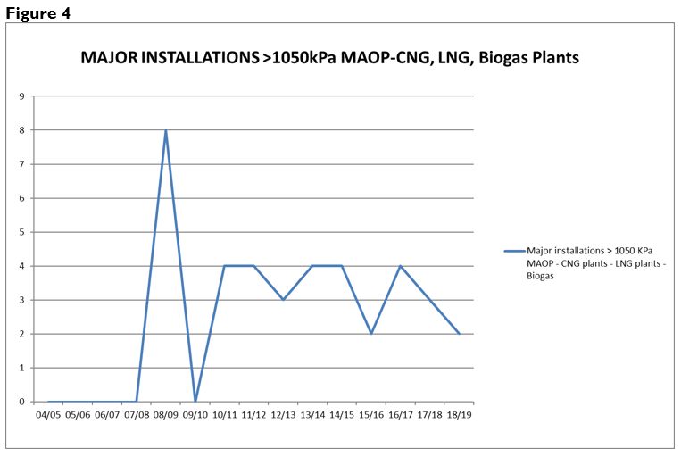

Prescribed Standard Gas Installation Acceptance
The Director of Gas Safety remains focused on safety and technical design for multi-residential prescribed standard gas installations. This includes gas distributor’s gas metering system location and installation standards, and maintenance and operation of consumer installations with the principal owner of the prescribed installations, Housing Tasmania.
The Director accepted 10 submissions for prescribed standard gas installation connections. This continues the downward trend of total prescribed standard gas installation applications for acceptance received by the Director’s office.
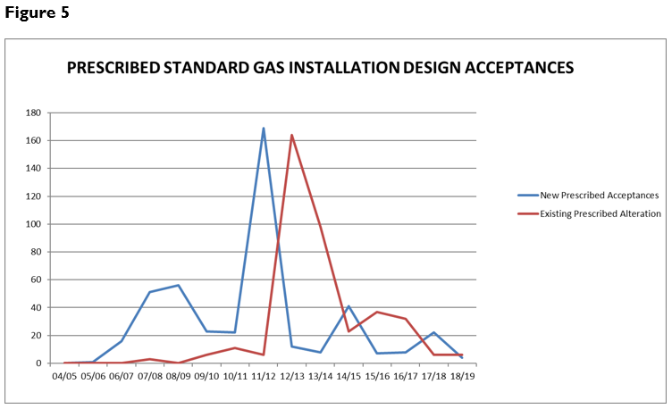

Type B Gas Appliance Acceptance
The Director’s office completed acceptances for 71 Type B gas industrial appliance designs. Following a 20% growth in in applications during the 2017-18 reporting period, this is a further 27% increase on that previous year. Significant projects continue to impact on the demand for the services of the Director’s office and staff expertise including acceptance and integrity management of the Ridley fish feed dryer and Royal Hobart Hospital.
Highly visual public displays, the Dark Mofo pyramids, flaming cross and woks, exploiting flame for artistic affect, and public food event continue to undergo significant review and acceptance including broad site safety provisions. This includes operational management and public safety for these unique type B appliances located, by nature, in close proximity to the public.
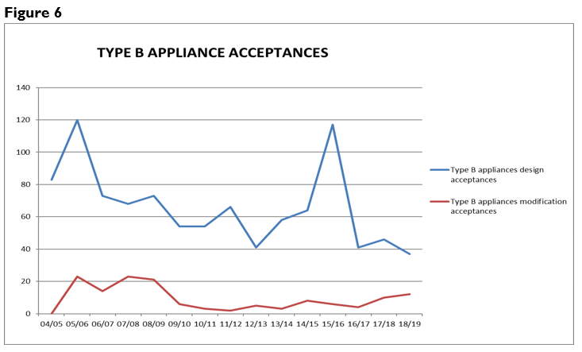
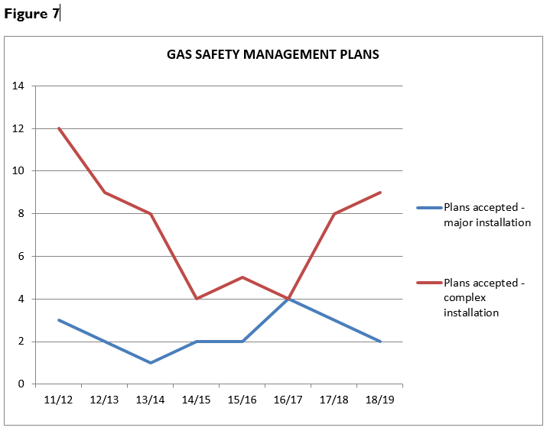
4.5 Type A Gas Appliance Class Certifying External Authorities
Six external authorities are approved by the Director to certify that Type A gas appliances and components are compliant with standards before being made available for sale in Tasmania. During the reporting period the Director received, assessed and approved an application from BSI Group Australia, including scheme rules and associated accreditations, for recognition as an external authority.
Energy Safety Victoria (ESV) audited the certifying bodies for the purpose of testing performance against appliance conformance standards. Performance reporting is supplied to each state and the Director accepts the interstate regulator’s audit results.
In conjunction with the Gas Technical Regulators Committee (GTRC), the Director aided development and implemented with recognised external authorities nationally consistent rules for gas appliance certification bodies. These rules provide for greater consumer protection owing to harmonised requirements across Australian and New Zealand jurisdictions and consistency of information to CABs and other stakeholders.
A cost benefit analysis has been conducted into increasing safety critical testing for high risks gas appliances identified through national incident data including BBQs, portable heaters and domestic cooking appliances. The results of this analysis is currently being discussed with appropriate stakeholders and any resultant actions are expected to be implemented in the latter half of 2019.

Table 4: Tasmanian approved gas appliance external authorities
Organisation | Address
Australian Gas Association | 66 Malcolm Road, Braeside, VIC 3195
BSI Group Australia | Suite 5.02, 484 St Kilda Road Melbourne VIC 3004
Global Mark Pty Ltd | Suite 4.07, 32 Delhi Road, North Ryde, NSW 2113
IAMPO R&T Oceana ‘Gas Mark’ | 1040 Dandenong Road, Carnegie, VIC 3163
SAI Global | 286 Sussex Street, Sydney, NSW 2000
Vipac Engineers & Scientists Ltd | 279 Normanby Road, Port Melbourne VIC 3207 Australia

4.6 Type A Gas Appliance Acceptance - Individual Appliance Certification Schemes
The Director maintains a policy that single gas appliances imported into Tasmania may undergo individual site safety certification and acceptance. This scheme allows unique new non-certified individual appliances to undergo inspection for safety certification against relevant technical standards determined by the Director. Appliance testing undertaken under the individual appliance scheme is less rigorous than laboratory assessment offered by main stream type testing schemes. Subsequently the scheme must be utilised for genuinely unique gas appliances as opposed to financial gain from importing gas appliances.
Two Tasmanian specific certification scheme approval occurred during 2018/19. Notwithstanding the decrease, the availability of overseas gas appliances through the internet is expected to maintain a demand for individual certification.
Individual appliance mutual recognition arrangements with interstate gas regulators are in place providing national consistency, system efficiencies and consumer choice. Legislation enables importation into Tasmania of unique appliances previously approved by other interstate regulators.

Prohibition of Sale, Product Withdrawal and Recall of Gas Appliances and Components
The Director has responsibilities pursuant to Section 79 A-C for prohibition of supply of unsafe gas appliances.
Due to proactive voluntary recalls and appliance remediation actions taken by gas appliance manufacturers and importers there were no prohibitions issued on the sale of unsafe and non-compliant gas appliances during 2018/19.
Modern building construction requirements including the lack of ventilation, and particularly where there is a negative pressure environment caused by operating kitchen range hoods or bathroom exhaust fans (or both), has caused concerns nationally with respect to open-flued gas heaters. The combination of a negative pressure environment and a non-compliant appliance significantly increases the risk of fatality or serious injury from carbon monoxide poisoning. In response, the GTRC required supplementary testing of all appliances of this type. These testing results resulted in the recall of four unsafe open flued heaters.
The Director’s office is actively assisting and supervising these open flued heater recalls including subsequent remedial programs within Tasmania.

Table 5: Tasmanian gas appliance and components prohibition of sale, product withdrawal, recall, and safety alert
Appliance | Action | Reason for Action
Amalgamated Hardware Merchants Ltd — Campmaster CM1950 Butane Heater | Voluntary local recall - Removed affected stock from the field. | If the product is not used in accordance with the operating instructions, elevated levels of carbon monoxide may be emitted when the knob is set at a specific position between ON and OFF.
Fireplace Products Australia - Regency i31 and F38 / FG38 Open Flued Space Heaters | Voluntary national recall, Connections magazine article, direct mail out to identified appliance owners. | Under certain circumstances the heaters produce too much carbon monoxide. There is a potential for carbon monoxide poisoning, causing serious health risk to users.
Glen Dimplex - Real Flame Pyrotech and Nectre 2000 Open Flued Space Heaters | Voluntary national recall, Connections magazine article, direct mail out to identified appliance owners. | Under certain circumstances the heaters produce too much carbon monoxide. There is a potential for carbon monoxide poisoning, causing serious health risk to users.
Honeywell – valVario gas valve | Removal of affected stock and targeted remedial program. | Valve body screws can break if valve is located or stored in a wet, humid or corrosive environment, resulting in gas leak.
Kmart Australia Ltd — 'Active & Co' and 'Jackeroo' Portable Single Burner Butane Gas Stoves | Voluntary local recall - Removed affected stock from the field | Gas leakage may occur while the product is in use.  If the defect occurs during use there is a possibility of fire or explosion.
Primus Australia – Companion COMP01023 and COMP01034 Butane Cooker | Removal of affected stock and targeted national recall program. | Gas valve can leak if a cartridge if reconnected after safety device activates.
Real Flame – LS 1000 and LS 16000 Space Heaters | Removal of affected stock and targeted remedial program. | Significantly higher gas consumption to that certified.
Rinnai Australia Pty Ltd — Rinnai Symmetry Inbuilt Gas Log Effect Space Heater | Voluntary national recall, Connections magazine article, direct mail out to identified appliance owners. | Delayed ignition due to low gas pressure causes the mesh-guard to separate from the front of the heater or the glass front to break, posing a risk of injury to the user.
Sitro Group Australia Pty Ltd — Gasmate Butane Heater Model BH10PL | Voluntary national recall, Facebook post | If used indoors on the lowest possible heat, dangerous combustion gas by-products may be produced.
Thetford Australia Pty Ltd - 3-Way Absorption Fridge | Voluntary local recall - Removed affected stock from the field. Regular retrofit repair updates. | If the test point nut is not correctly tightened, it could cause a gas leak, potentially leading to a fire
Vulcan /Pyrox Heritage Heaters | Inspection and remediation program, Director investigation and identification of installed heaters | If the house is well sealed and the heater is operating at the same time as a kitchen or bathroom exhaust fan, carbon monoxide from the heater can be drawn into living areas.

Major Events
Significant resources continue to be deployed to ensure public safety at significant Tasmanian events such as The Taste of Tasmania, Dark Mofo, Agfest, Taste the Harvest and Festivale. GSS continued to expand this successful regulatory and safety focus to include smaller boutique events in regional areas during the reporting period. Whilst gas installation compliance and safety is a primary emphasis, GSS also works with event organisers to develop and implement gas safety management plans for the safe use of gas appliances and emergency response in the event of a gas related incident.
Due largely to the increased public exposure to risks at major events the Director provides comprehensive guidance material for both the storage and use of LP gas at public events, and the assessment and use of temporary flame effects operated before an audience. Following consultation with the Department of Health the Director contributed to the development and distribution of explanatory material providing clarification in respect to an apparent contradiction between mobile food business guidelines and LP Gas storage safety standards.
Because of the transient nature of temporary food vendors GSS have implemented a database to encourage regional consistency and ensure compliance instructions provided are followed up on at the next event a vendor attends.

Internet Sale of Gas Appliances
The sale of new, non-certified products imported into Australia and purchased via the internet by consumers continues to be difficult for gas regulators to regulate.
Wholesaling of gas appliances via internet-based sales sites without appliance certification is creating an unacceptable void in the appliance safety certification scheme and increasing risk to the public.
The Director continues to investigate regulatory options, in consultation with other jurisdictions. This has progressed to participation in the National Product Safety Operations Group focusing on compliance in the online marketplace.

Carbon Monoxide
A carbon monoxide awareness program continues to be a priority of the Director and the program is consistent with the national strategy for exposure to carbon monoxide.
A significant safety focus has resulted from the death of a woman in Victoria from exposer to carbon monoxide emitted from an open flued gas heater. Subsequently, the Director is actively working with other national gas technical regulators, certification assessment bodies, suppliers, gasfitters and the manufacturers of open flued gas heaters to ensure the ongoing safety of the Tasmanian public.
This has resulted in supplementary safety testing, against contemporary Australian standards, of all open flued gas heaters available on the Australian market to ensure adverse flue flows cannot expose the public to risks posed by carbon monoxide. Safety testing of open flued heaters resulted in national safety recalls across four heater models, manufactured by two separate manufacturers. The Director continues to engage with relevant manufacturers in respect to the approval of remedial actions to render these appliances safe, and with the identification of the location of heater installations to enable a targeted remedial program.
In addition the Director of Gas Safety is involved in the education of gas fitters on the safety testing of all open flued gas heaters they install and service through Connections Magazine articles, joint state wide training sessions in partnership with Master Plumbers Association Tasmania and implementation of minimum heater service compliance standards. More broadly, public focused open flued heater safety educational programs have included warnings on the installation of air extraction systems and the safety benefits of regularly servicing appliances.

Gas Installation and Appliance Incidents
GSS has responded to 17 gas storage, installation and appliance incidents in this reporting period. This supports the decrease reported on by the Director last year (refer figure 10), providing confidence in the Director’s risk based targeted intervention programs.
Portable LP Gas storage and appliance incidents remain the predominant cause of incidents incident resulting in thirteen investigations, which contrast with natural gas installations that only accounted for four. These Tasmanian statistics are consistent with national trends showing a disproportionate number of incidents involving the use of portable gas storage and appliances compared to other forms of gas installation. This has compelled national gas safety regulators to investigate the replacement of the current POL connection between gas cylinders and appliances. Following considerable industry and stakeholder engagement the roll out a safer leisure cylinder connection (QCC Valve) is expected to commence mid to late 2020.
The continued collection and maintenance of reliable local and national incident data allows the Director to identify trends in incident root cause. As a result, this has allowed the Director’s office to provide appropriate targeted program strategies in respect to open flued heater and carbon monoxide safety including management of appliance recalls, Australian Standards development, and public and gas fitter education.
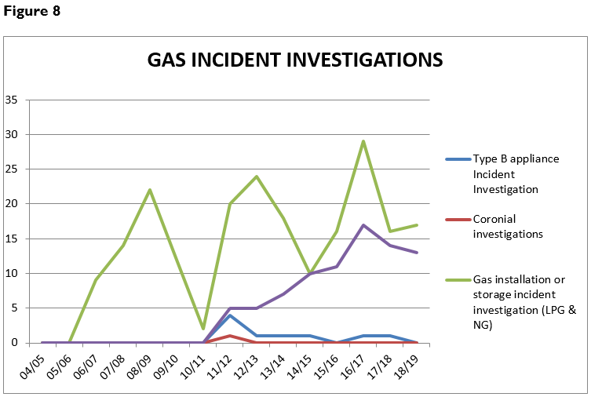

SECTION 5: Office of the Director of Gas Safety Programs/Achievements
The Director has accomplished all reactive programs and is nearing completion of the Gas Safety Legislation restructure including the development of valuable and accountable regulatory models to meet public safety expectations.
The following programs are mandated under the Gas Act 2000 and the Gas Pipeline Act 2000.

Table 6: Operation and maintenance of administrative systems primary outputs
Industry Segment | Business Management System | Output | Reason
Management | Annual report output and statistical collation | Annual report on activities of the Director | Legislative requirement Gas Act 2000
 | Time allocation data collation for gas entity activity | Time records | Recovery of reasonable cost pursuant to Gas Act 2000
 | Communicate with national gas regulators | Maintenance of technical and evolving standards | Safe gas installations and appliances
 | Policy development | Monitoring, review and improvement of legislation and prescribed standards | Maintain contemporary regulation in an ever evolving industry
Business administration and appliance programs | Business document control | Administer the document and publications register | Maintenance of document and publications standards
 | Web development and management | Review and update the gas website | Quality control of public documents
 | Communications management system | Internal delivery of relevant and timely publications | Identify safety, training and educational needs and stakeholder expectations
 | Gas appliance (Type A) safety management | Identify and implement unsafe gas appliance notifications | Consumer safety
 | Gas appliance approval (Type A) program | Conduct safety approval procedures for appliances and establish national alliances | Consumer safety
 | Gas External Authority approval | Ensure competent organisations are approved to examine gas appliance safety | Consumer safety
 | Accident and incident investigation program | Respond to accidents and incidents on gas transmission, distribution and installations that pose a risk to supply and public safety. | Community safety  Gas emergency response

Industry Segment | Business Management System | Output | Reason
 | Undertake commercial sensitivity assessment of gas infrastructure information records | Deliver timely Freedom of Information requests | Preserve information confidentiality
 | Gas safety management plan (GSMP) acceptances | Ensure adequate GSMP for large or high risk installations | Safety and reliability of installations
Gasfitter administration | Gasfitter installations notification database | Gasfitter certification data | Verify gasfitter certifications of gas installations
 | Gas installations Acceptance program | Deliver 3 regional installation technical compliance programs | Consumer safety
 | Gas appliance design and installation acceptance (Type B) | Deliver 3 regional Type B appliance technical compliance programs | Consumer safety
 | Gasfitter education and management of CPD opportunities | Deliver targeted training and accept external CPD training | Legislative requirement Occupational Licensing Act 2005, Consumer Safety
 | Gasfitter Licence applications | Verify and endorse gasfitter licence applications | Legislative requirement Occupational Licensing Act 2005, Consumer Safety
Gas Distribution | Gas Entity network approval program | Review proposed network submissions | Ensure construction standards compliance
 | Gas Entity network integrity monitoring | Review of safety and operating plans | Ensure acceptable levels of public risk and supply integrity
 | Installation disconnections and reconnection procedures. | Deliver timely disconnection orders | Control unsafe or non-compliant gas installations
Gas Storage and Conditioning | Gas Storage Systems | Design acceptance and supplier / stakeholder management project | Target supplier compliance in existing and new gas storage products
 | Gas Storage Systems safety management and emergency response planning | Approval of GSMP | Consumer and public safety enhancement

Regional Delivery of Programs
The Director continuously improves programs to meet the expectations and safety outcomes of industry and the public in line with the broader CBOS Strategic Plan. Programs that have substantially reduced the regulatory and public risk posed by historical constraints include proactive inspections of standard gas installations, increased enforcement activity in conjunction with the Occupational Licencing unit and increased use of compliance data to target and align regulatory activities with demonstrated risks.

Table 7: Summary of Achievements
Activity | Function | Safety Outcome
Gas Distribution and Storage
Audit implementation of risk reduction measures and infrastructure management plans | Ongoing pipeline integrity and public safety | Reduce levels of public risk and enhance reliability
Review network formal safety assessments and safety management systems | Ensure ongoing contemporary, safe and compliant system design | Maintain infrastructure safety and control public risk
Contribute to the development of appropriate safety standards | Contributing members of Australian standards committees for gas networks, and gas storage | Protection of public through contemporary compliance standards
Tasmanian gas supply emergency management | Tasmanian Jurisdictional Contact Officers under national (NGERAC) planning frameworks. Stakeholder engagement and development of stakeholder obligations | Enhance Tasmanian natural gas supply emergency planning
Investigated uncontrolled gas release incidents on gas infrastructure including successful prosecution for excavating in the vicinity of gas infrastructure without permission | Identify causation of incidents, review operational standards and instigate regulatory actions | Prevent recurrence of uncontrolled gas incidents, and ensure acceptable levels of public risk
Reviewed network reliability, integrity, operational management, public safety and condition survey | Ensure compliance, adequacy, currency, accuracy and reliability of operational records | Maintain supply safety and control public risk
Reviewed development of gas entity operations pipeline integrity management plans | Ensure compliance and adequate management of gas infrastructure through documented policies and procedures | Maintain supply safety and control public risk
Compliance audit program for LNG gas pipeline facilities | Ensure compliance of emergency response and planning | Maintain infrastructure safety and control public risk
Gasfitter Licensing and Gas Worker Accreditation
Collaboration with stakeholders to identify required training and skills development for CPD | Ensure that comprehensive standards for training | Ensure that competent persons undertake all forms of gas fitting work
Developed and delivered targeted training to wider gas fitting industry | Maintain gas fitter competency around topical technical issues | Ensure gas installation compliance and standards providing adequate level of consumer safety
Investigated non-compliant gas installation work standards and resultant safety issues | Issue gasfitter defects, infringement, consumer disconnect and rectification notices | Ensure gas installation safety standards for consumers
Provided advice and conducted investigations | Ensure compliant gas fitting and licensing standards | Ensure safe gas fitting and licensing standards
Gas Appliances and Installations
Contribute to the development of appropriate safety standards | Contributing members of Australian standards committees for type b appliances | Protection of public through contemporary compliance standards
Investigated uncontrolled gas incidents on in situ and portable gas appliances | Identify causation of incidents and review technical standards | Prevent reoccurrence, produce education materials, web information and implement product withdrawal standards
Collaborated with national gas technical regulators on gas appliance safety concerns and initiate actions in respect to appliance certification bodies, suppliers and consumers | Minimise the likelihood of death or injury from exposure to unsafe gas appliances | Protection of consumers
Implemented open flued heater and carbon monoxide education program | Minimise the likelihood of death or injury from exposure to carbon monoxide | Prevent reoccurrence and provide education
Continued to research, review and adopt relevant technical standards and codes for gas appliances | Develop, in conjunction with GTRC, appliance certification scheme rules | Ensure a consistent and robust national appliance certification scheme that effectively delivers safety outcomes for ever increasing imported products
Continued to develop and implement gas safety management planning for LNG, CNG, Bio Gas Storage | Ensure gas storage systems installations achieve acceptable levels of risk control and emergency preparedness | Manage consequences and inherent risks
Gas Technical Standards and Working Groups
Tasmanian gas supply emergency management including development of network gas quality excursion protocols | Tasmanian Jurisdictional Contact Officers under national (NGERAC) planning frameworks. Stakeholder engagement and development of stakeholder obligations | Tasmanian gas supply emergency management including development of network gas quality excursion protocols
Participated in development of Australian safety standards | Ensure evolving gas appliance, installation, infrastructure and non-conventional gas developments achieve acceptable levels of risk control | Set contemporary design, installation, commissioning and operational specifications
Stakeholder Relations
Facilitated stakeholder meetings for the management of buried infrastructure | Development of safe work procedures for work adjacent to buried infrastructure | Ensure worker safety, recording and quality of location information
Continued to facilitate gas entity meetings for the management of safe gas infrastructure | Maintain adequacy of management communications | Ensure safety and reliability of Tasmanian NG supplies
Contributed to national Gas Technical Regulator Committee programs | Harmonise gas product and legislative outcomes to national and COAG standards. | Maximise safety and economic outcomes to gas consumers
Communications and Education Management
Provided industry specific training presentations including regional forums and open flued heater adverse flow training | Provide targeted guidance in respect to ground works adjacent to buried gas infrastructure, and gas fitting work standards | Manage public risk by ensuring relevant industry stakeholders are aware of their obligations and safety expectations
Administered a gas specific internet site and gas safety publications | Facilitate stakeholder and consumer access to gas technical standards and safety information | Provide timely delivery of industry communications products
Contributed articles to Connections trade and consumer magazines | Improve stakeholder and end user education on gas safety | Enhance gas education policy and expand audience
Issued Guidance Notes following investigations | Provide stakeholder advice | Enhance safety of civil and gas workers
Business Administration
Administered, reviewed and identified opportunity for business management improvement | Continue development of risk based business unit models | Efficiently administer all business processes
Review of document standards for web viewing | Improve industry efficiencies | Enhance timely delivery of services
Continued targeted recruitment | Ensure adequacy of regional safety and technical coverage thus improving output in line with industry and community expectations | Ensure acceptable staff workloads and enhance timely delivery of services
Policy Development
Review of Act and Regulations | Ensure adequate and improved regulatory requirements to facilitate safe outcomes in an evolving industry | Provide consistent and contemporary gas safety framework

Inspection Program
Demand for Gas Standards and Safety’s complex, prescribed standard gas installation and type B appliance inspection remained stable this reporting year. To ensure appropriate management of resources, the Director’s office examines the inherent risk of individual installations and appliances to enhance field-based inspection programs. This resulted in increased onsite inspections of installation safety and compliances as opposed to desktop design assessments (refer figures 9 and 10)
Due to the Director’s belief that standard gas installations and portable appliances are the greatest organisational risk confronting this office, GSS continued to intensify its proactive regional ‘standard’ gas installation inspection schedule. Targeted recruitment also provided a dedicated state wide role for the management of standard gas installations, substantially reducing the regulatory and public risk posed by historical constraints.
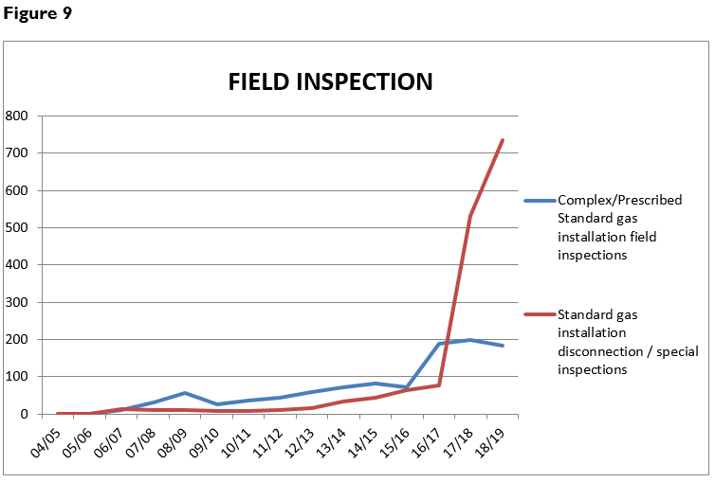

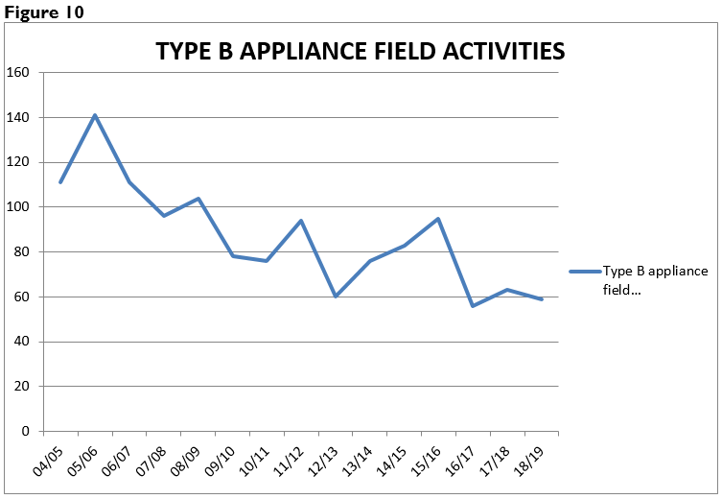

Technical Standards Development
Development of safety and technical standards for the Tasmanian gas industry is undertaken to meet emerging trends and technology advancements. Consultation between industry stakeholders, end users, interstate regulators and gas industry organisations is ongoing to ensure currency, relevance and completeness of Tasmanian gas standards.
The Director’s office routinely provides technical comment and feedback to Australian Standards committees in respect to proposed amendments and drafts (refer Table 9).
The Director is also represented by GSS on Australian Standards committees ME-093 Hydrogen Technologies, AS 3814 Industrial gas appliances (AG-001-00-05), AS 1596 The storage and handling of LP Gas (ME-15) and AS/NZS 4645 Gas distribution networks (AG-008).
Considerable resources is expected in the provision of input into the evolving hydrogen industry standards as they are developed to manage the safety of hydrogen production, utilisation in the transport sector, storage and handling, transportation/distribution and end-use utilisation with respect to appliances installations.

Table 8: Technical Standards Development and Implementation 2018/19
Standard | Title | Revisions
AS/NZS 2885.2 | Pipelines—Gas and liquid petroleum , Part 2: Welding | Clarification of chimerical analysis for boron content, hydrogen in weld metal management and clarification of engineering critical assessment expectations.
AS 4575 | Gas appliances – Quality of servicing | Amended essential specifications for the delivery of Type A appliance servicing, repair, testing and conversion to reduce risks posed by open flued gas appliances and carbon monoxide.
AS 5263 | Gas appliances | Amendments aimed at providing additional gas appliance safety and performance assurances for manufacturers, designers, regulatory authorities, testing laboratories and similar organisations including a new part covering small gas engines.
Multiple |  | Amendments to facilitate the implementation and roll out of safer QCC LP gas cylinder connection valve in the leisure gas portion of the industry

Vehicle Gas Fitting and Stationary Engines
While the vehicle gasfitter worker competency training package for LNG, CNG and LP gas vehicle gasfitters by TasTafe and the worker licensing scheme by CBOS are operating effectively, the commercial uptake of gas as an automotive fuel continues to slow.
On the other hand, the Director continues to accept accepted stationary reciprocating and rotating engines for the generation of electricity, both as an emergency backup and primary generation. In the current energy climate the Director expects this trend to continue.
No new work was undertaken by the Director’s office in respect to the technical compliance for the vehicle gas fitting industry including automotive gas fitting work notifications. Further development in this area is reliant on the implementation of the Gas Safety Act 2019.

Gas Committees and Associations
The Director remained actively involved as a member of the GTRC. Membership of this national committee provides Tasmania with current gas appliance and gas technical and safety information exchange, including products withdrawn from market, illegal sales of equipment, and audit results by interstate regulators on appliance certifying bodies. GTRC member communications frequently result in product warnings to the Tasmanian public, gasfitter communications and appliance safety investigations.
In addition to reactive state based gas supply coordination role, the Director is also the Tasmanian Jurisdictional Contact Officer (JCO) for the purposes of the National Gas Emergency Response Advisory Committee (NGERAC). This permitted the Director’s office participated in a valuable national energy curtailment emergency exercise that highlighted energy interrelationships due to gas fired electricity generation.

Table 9: Participation in committees and organisations
Committee | Member organisations | Committee purpose
Gas Technical Regulators Committee (GTRC) | All Australian States and New Zealand gas technical regulators | Harmonisation of national gas safety standards.  Industry communications.  Acceptance of external authority performance audit.
National Gas Emergency Response Advisory Committee (NGERAC) | Federal jurisdictions, Gas infrastructure owners,  GSS, Department of State Growth | Facilitate efficient and effective communication across industry and government during major national natural gas supply shortages.
Australian Standards Committees | Numerous | Provide Tasmanian input into evolving issues and continual improvement of technical standards for public and infrastructure protection.
POL Working Committee | Australian States and New Zealand gas technical regulators and LP Gas industry stakeholders | Investigate the replacement of the current LP gas cylinder valve to appliance connection for something safer
Tasmanian Gas Fitter Competency Standards Committee | GSS, Master Plumbers Association Tasmania, TasTAFE and occupational Licensing | Ensure adequate and appropriate learning outcomes for gas fitters

Policy Development and Legislation
Significant resources have been required to undertake a major review of both the Gas Pipelines Act 2000 and the Gas Act 2000. The purpose of the review being to separate the economic/licensing functions administered by the Department of State Growth and the technical/safety functions administered by the Director of Gas Safety and Department of Justice. These functions are currently combined in both sets of legislation and in many cases are not clear.
The Gas Safety Bill and Gas Supply Industry Bill passed both houses of Parliament and received Royal Assent on 9th April 2019. Proclamation and subsequent implementation of these Acts of Parliament is expected to occur in the latter half of 2019, following the drafting and stakeholder review of ensuing Regulations.
Resources were also required to review and comment on the Tasmanian Planning Commission draft Local Planning Scheme Rules with respect to managing pipeline planning corridors. Pipeline planning corridors provide for the safe operation of gas infrastructure by ensuring that gas infrastructure owners are appropriately notified if there is a development application that impacts on the safety of the infrastructure and/or public.
  - Communications and Gas Safety Education
Development of educational information to inform stakeholders of legislative and technical matters has remained a focus during 2018/19. See Table 10 for outputs of this program.
To ensure new gasfitters receive sufficient training to ensure ongoing public safety the Director continues to scrutinise the national Industry Reference Committees for Construction, Plumbing and Services and Skills Service Organisation, Artibus in their work reviewing, renewing and developing vocational education and training (VET) within the gas fitting sector.
Due to the risks posed by unsafe gas fitting work within recreational vehicles, in consultation with the Administrators of the Occupational Licencing Act 2005 the Director has developed and rolled out a caravan refresher course that must be undertaken prior to practitioners renewing their caravan gas fitting licence endorsement.

Table 10: Communication products
Program | New or Managed Output 2017/18 | Target Audience
GSS website | Maintained gas safety and technical standards website | Gas consumers  Gasfitters  Gas workers  Gas distributors  Community  Rural landowners  Infrastructure owners
Connections magazine | Up to date gas consumer safety and technical gas topics | Gas consumers  Gasfitters
Presentations | Gas fitting standards and open forum | Gasfitters
 | Carbon Monoxide Testing – Practical Test Procedures | Gasfitters
 | Hydrogen presentation by CSIRO | Gasfitters
 | Gas Safety and role of GSS | TasTafe gas fitting classes
Gas safety and technical publications | Carbon Monoxide publications including awareness brochure distributed to every Tasmanian Household | Gasfitters  Consumers  Community
Gas safety and technical publications | CO awareness fact sheet | Gasfitters  Installation owners
 | Newly licenced gas fitter booklet providing information on how to navigate the Tasmanian safety and regulatory environment | Gasfitters  Installation owners  Installation designers
Expos and other public events | AGFEST and HIA Home and Building Expo | Gas consumers  Gasfitters  Gas workers  Community  Rural landowners  Civil Contractors  RV industry
Social media (Facebook) | Provide gas appliance safety and recall information and links to public and industry | Gasfitters  Consumers

Gas Supply Management
As reported previously the Director is assigned the role of Tasmanian Jurisdictional Contact Officer (JCO) under the National Gas Emergency Response Advisory Committee (NGERAC). Meetings of the Natural Gas Supply Emergency Coordination Committee were not convened by the Department of State Growth during this reporting period. This has required the Director to further resource the coordination and response to supply emergencies for the purpose of advising the Minister on how to respond to natural gas supply situations.
A staff availability roster is operational for after-hour response to onshore gas infrastructure and installation incidents, as well as intrastate, interstate and offshore supply or gas quality issues. This proved invaluable during a local gas supply incident that resulted in the loss of gas supply to 101 gas consumers connected to the Longford (Tas) distribution network. Gas supply was lost due to failure of a gas water heater designed to heat gas prior to pressure reduction and required significant network recovery activities.
Ongoing gas supply emergency response exercises provided valuable learning opportunities with respect to communication protocols between the Department of State Growth, Australian Energy Market Operator (AEMO), NGERAC and the Director. This also offered the opportunity to consider responses and interoperability processes when managing major electricity and gas supply shortfalls.
Determination of minimum gas supply volumes required to maintain supply to essential services that are critical to the Tasmanian public were incorporated into Phase 1 of NGERAC’s base load modelling study. This information improved understanding during the Director’s involvement in weekly summer energy outlook summaries. These briefings were aimed at enhancing industry communication and response protocol, and the preparedness of GSS’s emergency call out and response to incidents that occur after-hours.

Emergency Incident Coordination
The Director maintains management plans and internal procedures for ‘on shore’ emergency gas incident response. Emergency Incident Response Management plans and the staff availability roster have operated successfully to cater for an expanding use of different fuel gases and complexity in gas supply chain management. As a result the Director of Gas Safety’s incident response management program continues to enhance enforcement of real time isolation of uncontrolled gas escapes and incident recovery activities.
Response to 29 installation and supply incidents during the reporting period and total of 338 over eleven years of implementation has been beneficial to Tasmania Fire Service and Tasmania Police in responding to incidents and ensuring safe procedures for gas isolation and recovery.

SECTION 6: Inter-government Industry Administration
Collaboration with the Office of the Economic Regulator ensured a smooth path for pipeline and retailer approvals, licensing, and recovery of the Director’s reasonable costs from licensed gas entities. This will be further enhanced with the implementation of the Gas Safety Act 2018 and Gas Industry Act 2018 expected in the latter half of 2019.
Cooperation with the Tasmania Fire Service and Department of State Growth in relation to the fuel gas industry including hydrogen development, expansion of existing infrastructure and emergency management guarantees sound intergovernmental communications and increased response capability, which provides a consistent and harmonised response from government.

SECTION 7: Conclusion
Gas transmission programs pursuant to the Gas Pipelines Act 2000 have also required substantial resourcing including auditing of pipeline field activities and emergency response exercises demonstrating industries preparedness, integrity studies including cathodic protection and coating surveys, and investigation of an uncontrolled release emanating from a defective gas pressure regulator sensing line. The lessons learned from this investigation will require broad dissemination across industry stakeholders that utilise the same and similar equipment.
Ongoing diminished GSS unit staffing levels has hindered some programs however, the Director is confident that targeted intervention programs, implemented in line with the identified risk areas, continue to provide the public value, accountability, efficiencies and effectiveness expected by stakeholders. This includes the introduction of a greater enforcement focus on those matters involving interference with gas infrastructure, diversion and abstraction of gas, gasfitter work standards with a particular focus on standard gas installations, pipeline integrity, gas conditioning, gas storage and new compliance standards.

Andrew Goldsworthy
DIRECTOR of GAS SAFETY (Acting)

APPENDIX 1: Glossary and Abbreviations

CBOS | Consumer, Building and Occupational Services
CNG | Compressed Natural Gas
COAG | Council of Australian Government
Director | Director of Gas Safety
GSMP | Gas Safety Management Plan
GSS | Gas Standards and Safety (Unit of CBOS)
GTRC | Gas Technical Regulators Committee
JCO | Jurisdictional Contact Officer
kPa | Kilo Pascals
LNG | Liquefied Natural Gas
LPG | Liquefied Petroleum Gas
MAOP | Maximum Allowable Operating Pressure
NEMEMF | National Electricity Market Emergency Management Forum
NGERAC | National Gas Emergency Response Advisory Committee
NG | Natural Gas
PIG | Pipeline Integrity Gauge
TGP | Tasmanian Gas Pipeline

