Operations Implemented under the Gas Act 2000

Annual Report
2017/18

REPORT OF THE DIRECTOR OF GAS SAFETY
This is the annual report of the Director of Gas Safety pursuant to the Gas Act 2000. It describes the operations of the Director’s office for the financial year 2017/18 as required by Section 16 of the Act.
The Director of Gas Safety is a statutory appointment established by Section 9 of the Gas Act 2000. Mr Dale Webster held this position for the period covered in this report.
The Gas Act 2000 requires the Director of Gas Safety to deliver to the Minister a report on the Director's operations during the previous financial year. The Minister must cause a copy of each report to be laid before both Houses of Parliament.
Director of Gas Safety: Dale Webster
Office: Consumer, Building and Occupational Services
Office Address: 30 Gordon Hills Road, Rosny Park 7018
Postal Address: Director of Gas Safety
PO Box 56
Rosny Park 7018
Telephone: 1300 654 499
Office hours: 9:00am to 5:00pm, Monday to Friday
(except public holidays)
Website: www.justice.tas.gov.au
Email: cbosinfo@justice.tas.gov.au

Preface
This report covers the Director of Gas Safety’s operations under the Gas Act 2000 (the Act) as it was in force for the 2017/18 financial year.
Section 4 of the Act states that the objectives of the Act are:
- to facilitate the development of a gas supply industry in Tasmania; and
- to promote efficiency and competition in the gas supply industry; and
- to promote the establishment and maintenance of a safe and efficient system of gas distribution and supply; and
- to establish and enforce proper standards of safety, reliability and quality in the gas supply industry; and
- to establish and enforce proper safety and technical standards for gas installations and appliances; and
- to protect the interests of consumers of gas.
The Director of Gas Safety is appointed in accordance with Section 9 of the Act.
Section 10 of the Act states that the Director of Gas Safety has the following functions:
- the monitoring and regulation of safety and technical standards in the gas supply industry;
- the monitoring and regulation of safety and technical standards with respect to gas installations and gas appliances.
The Director of Gas Safety, in administrating the Act, participates in a range of activities in cooperation with the gas industry and other Government agencies. This includes gas entity licensing functions and gas emergency management vested with the Regulator and Minister for Energy, Department of State Growth respectively.
The Director’s actions in relation to these functions are dealt within this report.

Table of Contents
REPORT OF THE DIRECTOR OF GAS SAFETY 2
Preface 3
Office of the Director of Gas Safety 6
Vision 8
SECTION 1: Gas Distribution 9
Table 1: Tasmanian Network Location of Natural Gas Distribution Networks and Isolated LP Gas Networks 10
1.1 Natural Gas Rollout 10
1.2 Network Incident and Accident Reporting 10
1.3 Gas Distribution Entity Safety and Operating Plan 11
1.4 Gas Distribution Standards 11
1.5 Distribution Network Equipment and Integrity Management 12
1.6 Dial Before You Dig 12
1.7 Isolated Gas Networks 13
1.8 Gas Distribution Network Life Cycle Auditing 13
Table 2: Director’s Gas Network - Life Cycle Administration and Safety Program 13
1.9 Annual Distribution Gas Entity (TGN) Performance Report 14
Table 3: Gas Distributors Operational Performance 2017/18 (extracted from the Tas Gas Networks annual reporting data to the Director of Gas Safety 2017/18) 14
SECTION 2: Gas Retailing 15
2.1 Gas Retailer Emergency Gas Curtailment Planning 15
SECTION 3: Gas Suppliers, Storage Systems and Conditioning 16
3.1 Liquefied Natural Gas (LNG) 16
3.2 LP Gas (LPG) 16
3.3 Compressed Natural Gas (CNG) 16
3.4 Biogas 17
Table 4: Gas Storage and Conditioning Plants 17
SECTION 4: Gas Installations and Appliances 17
4.1 Notification and Certification 18
4.2 Complex Gas Installation Design Acceptance 18
4.3 Prescribed Standard Gas Installation Acceptance 19
4.4 Type B Gas Appliance Acceptance 20
Table 5: Tasmanian approved gas appliance external authorities 22
4.6 Type A Gas Appliance Acceptance - Individual Appliance Certification Schemes 22
4.7 Prohibition of Sale, Product Withdrawal and Recall of Gas Appliances and Components 23
Table 6: Tasmanian gas appliance and components prohibition of sale, product withdrawal, recall, and safety alert 23
4.8 Major Events 25
4.9 Internet Sale of Gas Appliances 25
4.10 Carbon Monoxide 25
4.11 Gas Installation and Appliance Incidents 26
SECTION 5: Office of the Director of Gas Safety Programs/Achievements 26
5.1 Regional Delivery of Programs 27
Table 7: Operation and maintenance of administrative systems primary outputs 27
Table 8: Summary of Achievements 29
5.2 Inspection Program 32
5.3 Technical Standards Development 34
Table 9: Technical Standards Development and Implementation 2017/18 34
5.4 Vehicle Gas Fitting and Stationary Engines 35
5.5 Gas Committees and Associations 35
Table 10: Participation in committees and organisations 35
5.6 Policy Development and Legislation 36
Table 11: Communication products 36
Gas safety and technical publications 37
Expos and other public events 37
Social media (Facebook) 37
5.8 Staff Development 37
Table 12: Staff development 37
5.9 Gas Supply Management 38
5.10 Emergency Incident Coordination 39
SECTION 6: Inter-government Industry Administration 39
SECTION 7: Conclusion 39
APPENDIX 1: Glossary and Abbreviations 41

Office of the Director of Gas Safety
The Director of Gas Safety, Mr Dale Webster, is supported by the Office of the Director of Gas Safety, Gas Standards and Safety (GSS).
The GSS unit is managed by the Assistant Director - Gas Safety, Mr Andrew Ayton, who is delegated the functions of the Director.
The GSS unit operates within the structure of Consumer, Building and Occupational Services (CBOS) branch along with Building Standards, Electrical Standards, Compliance and Dispute Resolution, Consumer Affairs, Corporate Affairs, Rental Services and Occupational Licensing and Accreditation.
This structure enables resource and knowledge sharing which results in efficiencies between technical and non-technical units for energy safety administration. GSS values and CBOS Strategic Plan provides for continual improvement including assurances that current programs are providing public value in the most efficient and effective way.
GSS are continually investigating methods to increase public safety program effectiveness. The capture of gas fitting work inspection data has allowed the implementation of tailored intervention programs aimed at decreasing community’s exposure to harm through a reduction in gas-fitting non-conformances and resultant incidents. This is complimented by a new CBOS web site and greater use of social media to provide convenient availability to gas safety information.
The Office of the Director of Gas Safety comprises five Authorised Officers and one Administrative Officer, with additional administrative support from CBOS administration and records staff.
Administrative and industry performance functions are centralised in Launceston, with the capability for gas industry safety and compliance programs in each region. Specialist policy functions are resourced from appliance installation and infrastructure Gas Safety Specialists in conjunction with the CBOS Policy, Projects and Communications team.
Resources, training and mentoring has enabled a fully supported regionally based technical and inspection program with the capability for all downstream installations and infrastructure inspection services, including individual industrial and commercial appliance (type B appliance) technical programs.
The GSS unit operational structure and activities are shown in Figure 1.
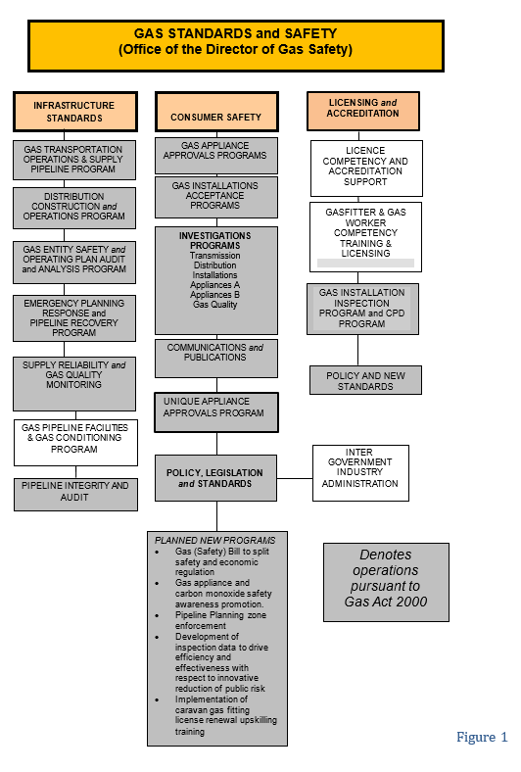

Vision
Consistent with the guiding aim of the Department of Justice to provide ‘A safe, fair and just Tasmania’, and in accordance with the role of the Director of Gas Safety, GSS strives to provide leadership and effective governance in respect to gas infrastructure, downstream installation safety and technical standards. GSS achieves this by ensuring the evolving natural gas, compressed liquefied natural gas, biogas and LP Gas industries achieve levels of excellence in construction, operations, reliable supply, acceptable public safety and energy efficiency.
The Director of Gas Safety will:
- ensure that gas infrastructure operations achieve high standards of safety, reliability and control inherent risks;
- provide advice to the gas industry to achieve best practice in gas safety;
- develop communication products and promote consumer understanding of gas safety through education and communication;
- work with industry stakeholders to ensure the efficient and safe evolution of gas technology and work standards for Tasmanian consumers;
- in conjunction with national jurisdictions, work to achieve desired levels of national harmonisation in the regulation of gas safety technical standards; and
- work to achieve contemporary program delivery models to enhance efficient operations.

We achieve our vision through the following values, expected from our team at all times.
Excellence: We strive for quality and excellence in our functions.
Respect: We treat all stakeholders and staff with respect.
Accountability: We take responsibility for our actions and decisions.
Integrity: We make decisions on merit, based on facts, logic and due process.
Commitment: We work cooperatively, mentor and support other team members to enhance development of the gas industry in Tasmania.
Cooperation: We work cooperatively, inclusively and are open in our dealings.
Creativity: We seek to solve problems creatively within the boundaries of prescriptive standards and codes.

SECTION 1: Gas Distribution
It is again satisfying to report that natural gas networks continue to provide a reliable supply of natural gas to an increasing number of consumers through Natural Gas Distribution Facilities operated under licence by Tas Gas Networks Pty Ltd (TGN).
Effective planning for natural gas supply/quality and the successful response to incidents by gas entities, Department of State Growth, major consumers and the Director’s office has prevented any major interruption to Tasmanian natural gas supply.
Three incidents involving gas supply shortfalls threatened natural gas supplies to Tasmanian centres. Mass consumer curtailment was averted in all instances because of extensive industry engagement and implementation of responsive actions.
Despite a reduction in incidents that resulted in an uncontrolled release of gas, the number of gas distribution network investigations increased during the reporting period. This is a result of an increased emphasis on investigating the vast majority of near miss third party activities. It is predicted that this approach, along with ongoing education programs, that this enforcement program will continue to reduce the high-risk gas release incidents.
The anomaly previously reported in the high-pressure steel network in Derwent Park Road, as the result of a strike by a horizontal direction drill, has been repaired. The repair involved in-service welding, hot tap, bypass cut out and replacement of the affected pipe. The repair required substantial regulatory oversight by GSS to ensure infrastructure integrity and reliability, and public safety.
The Director continues to maintain regular meetings with TGN to facilitate the open exchange on network operational and regulatory matters. These meetings have been held quarterly and have been of considerable benefit to both TGN and GSS.

Table 1: Tasmanian Network Location of Natural Gas Distribution Networks and Isolated LP Gas Networks
Existing Natural Gas Distribution Facility | Suburb / Town Receiving Gas Supply | Gas Facility, New Extensions Commissioned  2017/18 | New Facility Planning Reviews
BURNIE
BELL BAY
DEVONPORT | Central Business District |  | Redevelop and extend network to accommodate ‘Living City’ plans
HOBART | Multiple | 500 kPa network extensions in Argyle Street, Bath Street, Bathurst street, Bowen Street and Lenah valley | Lenah Valley project involves a new subdivision
GLENORCHY
LAUNCESTON | Invermay | Balfour Street  Lindsay Street | Extension and GMS to feed new Peppers Silo Hotel development
LONGFORD
ULVERSTONE | South Ulverstone | Distribution network construction yet to commence. | Preliminary designs ongoing
WESTBURY |  |  | Planning underway to redevelop letdown station and network
WYNYARD
Existing LP Gas Isolated Gas Facility
LAUNCESTON Glenara Lakes

Natural Gas Rollout
Natural gas network expansion and construction has been limited to an additional 2.37 kilometres. Natural gas network/s augmentation has been predominantly associated with major developments, with smaller additions to facilitate the connection of natural gas consumers when deemed commercially viable by TGN.
The Director is not aware of any intended major network extensions.

Network Incident and Accident Reporting
Incident and accident reporting by the distributor has been ongoing. Incident data is collated and assessed for trends to determine both the root cause and required risk controls, with data showing a decrease in the number of incidents for this reporting period. (Refer Figure 2)
GSS proactively increased monitoring of network infrastructure during the reporting period which has resulted in a reduction in uncontrolled gas release and network damage as a result of third party activity. The Director is confident this focus will continue to result in positive safety outcomes into the future.
Consistent with international indicators, third party activity remains the primary risk to buried gas infrastructure. Applying lead indicators in the prediction of major incidents, the Director’s actions have included undertaking a targeted prevention program aimed at less critical near-miss incidents. As a result, the Director distributed community awareness material in relation to pipeline planning corridors, to continually improve public appreciation of gas infrastructure and the possible consequences of encroaching on gas networks.
No injuries to employees or the public have resulted from any incidents, and gas network metering and isolation design has been compliant and acceptable.
Figure 2

Gas Distribution Entity Safety and Operating Plan
Following a comprehensive review by GSS the Director approved an amended gas entity safety and operating plan during the 2016/17 reporting period. The Director’s safety and operating plan approval is valid for 5 years unless a revised plan is required due to significant change to gas entity safety management systems or altered infrastructure hazards results in increased levels of risk.
The Director continues to measure safety, reliability and structural integrity performance against this current independently certified and accepted safety and operating plan for the gas entity’s natural gas networks.

Gas Distribution Standards
Gas Entity Tier 2 and 3 design and operation policy and procedures are living documents that are amended by the gas entity due to technological advancements and as risks are identified through formal safety assessments (FSA). Current gas entity standards are consistent with existing activities and compliance requirements. There were no significant amendments to distribution standards during the reporting period to warrant a review of independent design certification. With a focus on continual improvement, the Director receives and reviews periodic standard amendments and when needed will require independent certification to ensure conformity.
High pressure pipeline integrity is achieved by gas entities implementing a systematic approach to design, construction, operation and maintenance activities in conjunction with sound engineering principles prescribed in Australian standards. To ensure continued pipeline integrity the Director requested and reviewed a gap analysis against requirements contained within the recently published Australian standard for gas distribution networks, AS 4645.

Distribution Network Equipment and Integrity Management
Due to limited network extensions the regulatory focus remains on assessment and validation of infrastructure integrity and operational management. To maintain the structural integrity of assets the gas entity is required to review all factors that have a bearing on the pipeline every 5 years. Reviews include remaining life, location class, safety management study and pipeline coating assessments involving cathodic protection reviews, direct current gradient surveys, pipeline dig up surveys, and pipe wall integrity assessments using intelligent pipeline integrity gauge/s (PIG).
This program uses maintenance records, physical characteristics and operating history of the networks to predict the integrity of a given network. The Director received and reviewed these integrity studies for the Devonport, Launceston and Ulverstone steel networks during the reporting period.
The outcome of leakage survey monitoring programs are reported to the Director. This program ensures public risk is as low as reasonably practicable and detection measures are implemented to identify leakage. A total of 240 kilometres of network mains were surveyed for gas leakage (Refer Table 3). Two gas leaks identified at short intervals on the East Devonport 1000 kPa polyethylene network were found to be a result of construction faults and local stresses. As a result, monthly leakage surveys will be conducted until confident that similar risk factors have been excluded.
Hobart steel network continues to be operated at reduced pressure following identification and repair of an anomaly. The Hobart high pressure pipeline is operating safely and the reduced operating pressure has to date not negatively affected gas availability to consumers however, a request to increase the operating pressure is expected.

Dial Before You Dig
The Director strongly encourages the use of the Dial Before You Dig phone and internet service by all infrastructure owners and contractors undertaking civil excavation in the proximity of gas infrastructure.
Enforcement action, regular presentations and guidance information provided to Tasmanian trades and affiliated professionals endeavours to drive the use of the Dial Before You Dig system. In addition, the Director met with Tas Networks and TGN to examine a number of third party pipeline encroachments and discuss potential collaborative practices to ensure infrastructure integrity and worker safety.
However this reporting period saw a decrease in enquiries with 12,863 received by the Dial Before You Dig provider for Tasmania relating to distribution gas infrastructure. The reduction in Dial Before You Dig enquires can be partially explained by the substantial decrease in NBN rollout.

Isolated Gas Networks
No new isolated gas networks were constructed in 2017/18.
The Director receives annual audits for the single inset network at Glenara Lakes, Launceston to ensure the satisfactory implementation of the approved safety and operating plan. The second of these audits was received by GSS in the first quarter of 2018 and whilst it highlighted that leakage surveys had not been undertaken, other operations and maintenance activities including emergency response exercises, incident response, competency standards and third part activity management were deemed adequate.

Gas Distribution Network Life Cycle Auditing
The Director implemented a gas infrastructure audit policy during the reporting period that provided for a systematic, structured and consistent auditing approach across all gas infrastructure, gas entities and licensees. The policy outlines GSS audit principles and the underlying strategy adopted to ensure gas infrastructure is managed satisfactorily.
In line with the audit policy, the Director’s natural gas network and high-pressure distribution pipelines integrity management audits continued to be a priority during the reporting period included cathodic protection monitoring, pipeline repair activities, and operations staff competency.

Table 2: Director’s Gas Network - Life Cycle Administration and Safety Program
Formal Safety Instrument | Administrative Program | Purpose
Gas Entity – Pipeline Integrity management plan | Initial document and implementation review | Pipeline system design, construction, operation and maintenance activities, in conjunction with the application of sound engineering principles with due regard to safety
Gas Entity Pipeline maximum operating pressure review | 5 year review | Technical compliance and public safety
Steel pipeline integrity plan review | Direct current and ground variance for direct assessment | Detect and monitor deterioration of pipeline protective coating condition
 | Inline inspection of pipelines | Detect and monitor internal condition of pipe and its capability to operate at MAOP
 | Pipeline quality gas review | Detect out of specification product, frequency and effects analysis
 | Finalisation of electrical installations in hazardous areas audit | Maintain safe electrical installations at meter stations to ensure acceptable network reliability and public safety
Gas Entity - Full Safety Assessments of gas networks | Review of infrastructure hazards and currency of protective systems | Maintenance of public safety and pipeline management from encroachment
Gas Entity - Safety management systems | Review currency with operations and construction | Maintain acceptable network reliability and public safety
Gas Entity - Network design certifiers acceptance | Approval of Independent Design Certification | Technical compliance of new networks designs
Gas Entity Operations Auditing | Audit implementation of acceptance safety and operating plans | Maintenance of public safety through acceptable pipeline operations

Annual Distribution Gas Entity (TGN) Performance Report
In line with contemporary public safety strategies, nationally consistent reporting criteria provide lead safety and reliability indicators.
The ongoing adequacy and effectiveness of risk mitigation actions is determined from a review of lag (near miss) and lead indictors collated across reporting periods. These actions include safety critical operations, maintenance activities, hazard identification, training, network integrity and emergency preparedness.

Table 3: Gas Distributors Operational Performance 2017/18 (extracted from the Tas Gas Networks annual reporting data to the Director of Gas Safety 2017/18)
Statistics | Polyethylene Mains |  | Steel Mains
 | 500 kPa | 1000kpa | 5.0 MPa
Length of distribution network (kilometres) | 734.570 | 55.05 | 45.87
Public third party reported gas leaks | 137 | 0 | 0
Gas escapes on mains not caused by third parties | 0 | 0 | 0
Kilometres of network subjected to leak survey | 140 | 55 | 45
Leaks detected during surveys | 0 | 1 | 0
Leak repairs as result of surveys | 0 | 1 | 0
Emergency / Incident response
Level 4 incidents | 8
Level 3 incidents | 0
Level 2 or 1 incidents | 0
Emergency response exercises planned | 4
Emergency response exercises completed | 3
Average time to respond to emergency notification | 11.3 minutes
Longest time to respond to emergency notification | 20 minutes
Dial before you dig enquiries | 12,863
Third party interference where Dial Before You Dig enquiries were performed | 10
Operational performance
Scheduled audits | 482
Non-conformance identified | 0
Non-conformance not corrected in scheduled time | 0
Gas quality tests | 2
Gas quality excursions (including odorant) | 0
Pressure/ temperature excursions | 0
Cathodic protection system surveys conducted | 2
Unsatisfactory CP system test results | 0

SECTION 2: Gas Retailing
Retailing of natural gas to industrial, commercial and domestic retail consumers is undertaken by licensed gas entities Aurora Energy Pty Ltd and Tas Gas Retail Pty Ltd. Consumer connections to the natural gas network increased by 1% this financial year.
Communication with retailers has been restricted to consultation during three out of specification gas and gas supply shortage incidents.

Gas Retailer Emergency Gas Curtailment Planning
Gas retailer Safety and Operating Plans remained unchanged and continue to be aligned with industry agreed gas quality and emergency gas supply coordination provisions. Plans are reviewed on a five yearly cycle unless major changes to operational risk values require a review sooner, as prescribed.
The Director remains in the role of the Tasmanian Jurisdictional Contact Officer (JCO) under the National Gas Emergency Response Advisory Committee (NGERAC). NGERAC was not convened during the reporting period however, three gas supply disruptions from the BHP ESSO gas plant had the potential to adversely affect Tasmanian natural gas supplies.
The Director was involved in a weekly national teleconference over the summer period to discuss potential gas production/storage, weather and gas fired power generation matters to establish any potential threat to Tasmanian natural gas supplies.

SECTION 3: Gas Suppliers, Storage Systems and Conditioning
Independent certification of design, installation, testing and mechanical completion procedures for gas storage facilities CNG, LNG and LP Gas is required.
Co-operation with all gas suppliers continues to result in improved gas safety standards and compliance.

Liquefied Natural Gas (LNG)
Supply of LNG to industrial consumers is an alternate energy option for large and small consumers isolated from the NG transmission system. This has provided economic energy advantages for a number of consumers.
On the flip side, the financial viability of LNG as vehicle fuel has resulted in the winding up of this industry segment. This trend may well change if current and prosed LNG propelled shipping source their LNG from Tasmania.
Existing gas storage safety management systems are being implemented effectively in this sector of the fuel gas industry. This includes the review of LNG suppliers’ implementation of gas safety management plans for gas conditioning and storage facilities, and major installations. This has included preliminary review and consultation in respect to the BOC’s Westbury LNG gas pipeline facility safety case, which is expected to be accepted by the Director and implemented in the latter half of 2018.
GSS continues to audit the safe management of BOC’s Westbury LNG gas pipeline facility in consultation with the Major Hazard Facility (MHF) branch of Worksafe Tasmania. The audit undertaken this reporting period included an extensive review of safety management system performance. The audit scope centred on those systems designed to prevent and mitigate possible major incidents at the facility.

LP Gas (LPG)
LP Gas connections remain high in areas not serviced by NG networks.
Public safety for the LP Gas storage, supply, installation, marine vessel and vehicle gas conversion industries, has been maintained as part of the Director’s administrative role. This involves ongoing coordination and consultation between the Director, Worksafe Tasmania and LP Gas suppliers.
GSS also held meetings with all LP gas suppliers with the aim of increasing LP Gas supply location compliance and safety. This resulted in the review of delivery driver training, compliance checklists, and non-conformance reporting and follow up.

Compressed Natural Gas (CNG)
The CNG conditioning and storage process is managed under the Director’s gas safety management plan and gas storage approvals system.
The Self Point CNG facility owned and operated by natural gas distributor Tas Gas Networks (TGN) remains the solitary CNG dispenser in Tasmania. Further expansion of this fuel’s availability to industrial and commercial fleets has not yet eventuated.
Dependent on the success and viability of current Victorian gas infrastructure developments using CNG storage as a means of gas supply to isolated natural gas distribution networks, the Director anticipates the development of similar systems to supply isolated industrial and commercial precincts.

Biogas
Biogas (dairies, rural husbandry), municipal and industrial waste gas capture and combustion is driving new projects by commercial and industrial consumers to offset escalating energy costs and meet environmental expectations; methane being 50 times more harmful than carbon dioxide as greenhouse gas.
The expectation that the use of waste gas for energy generation will increase in the agriculture and water treatment industry is proving accurate due to the frequency of enquires received by the Director’s Office.
The Director is monitoring a number of field trials proving up biogas chemistry and volume for future co-generation and tri-generation projects. In addition the Director is currently conferring with importers of domestic scale food and human waste biogas digesters and TasWater continue to upgrade and make better use of biogas resources at waste water sites.

Table 4: Gas Storage and Conditioning Plants
Gas Type | Location | Gas Facility, New Infrastructure Commissioned 2017/18 | New Facility or Installation Approvals 2017/18
LNG | Huon Aquaculture | Self-contained LNG storage system supplying on water gas turbine generators
Bio Gas |  |  |  | Design enquiries for domestic scale food and human waste biogas digesters feeding electrical generation
Bio Gas | Municipal Waste Stations |  |  | Designs enquires for new and upgrades of Bio Gas installations at municipal waste stations and sewage plants

SECTION 4: Gas Installations and Appliances
The installation of new gas service connections continues to maintain a high demand for the Director’s natural gas installations and gas appliance, safety and technical compliance programs.
Applications for new and alterations/additions to existing Type B gas appliance and complex gas installation acceptances have marginally increased this year. The regulatory focus for these higher risk installations has transformed to greater on site compliance inspections, as opposed to desktop design reviews.
Traditionally resourcing only allowed reactive actions in respect to standard gas installations however, an increase by one full time equivalent position in 2017/18 financial year has enhanced this program’s productivity in line with industry and public expectations. This has resulted in 531 standard gas installation compliance inspections, 19% of all notified gas fitting work, resulting in substantial reduction in public risk.

Notification and Certification
The Gas Act 2000 installation, notification and certification procedures used by gasfitters to certify work compliance continue to operate effectively.
The Director is undertaking development of further improvements in the installation, notification and connections process by the development of electronic lodgement of applications for acceptance and certificates of compliance. This is a response to industry calls to streamline and upgrade current paper based processes. It is envisaged that the system will allow for integration of occupational licensing and other current data to drive educated risk based compliance programs and scheduling for gas installation safety and technical standards.
A minor number of gasfitter non-notifications of prescribed work continue to occur. In addition to regulatory actions under the Act, enforcement protocols have been developed in conjunction with the Compliance and Dispute Resolution unit within CBOS for regulatory action pursuant to the Occupational Licensing Act 2005. Measurement of the effectiveness of this cooperative enforcement approach is ongoing with five requests for enforcement escalation requested during the 2017/18 reporting year.
A notification form for the vehicle gas fitting industry has not been completed due to the delay in development of the Gas Safety Bill triggering applicable provisions in the Gas (Safety) Regulations 2014.

Complex Gas Installation Design Acceptance
A slight increase in complex gas installation submissions resulted in inspectors completing the design assessment of 226 complex gas installations, primarily at commercial sites. This prescribed function is essentially reactive to industry demand and linked to consumer gas uptake.
Energy efficiency and commercial retrofitting of steam, hot water and commercial catering gas appliances significantly influence GSS gas installation workload. Limited increase in network expansion, natural gas supply constraints and price increases, because of markets entering global demand pricing through exports of Liquefied Natural Gas, is expected to affect consumer confidence.
However the marked increase again in alterations and additions to existing gas installations illustrates that those that have previously shifted to gas as a source of energy have experienced benefits and are looking to further increase costs and business efficiencies.
A significant resource was allocated to the Simplot high-pressure consumer piping reviews requiring, remaining life, safety management system and pipeline integrity management plan reviews.
Figure 3

Figure 4
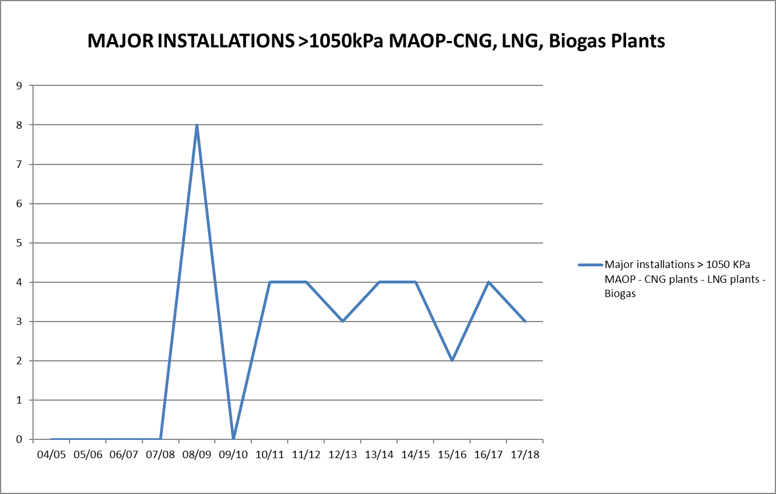

Prescribed Standard Gas Installation Acceptance
The Director of Gas Safety remains focused on safety and technical design for multi-residential prescribed standard gas installations. This includes gas distributor’s gas metering system location and installation standards, and maintenance and operation of consumer installations with the principal owner of the prescribed installations, Housing Tasmania.
The Director accepted 28 submissions for prescribed standard gas installation connections. This continues the downward trend of total prescribed standard gas installation applications for acceptance received by the Director’s office.

Figure 5
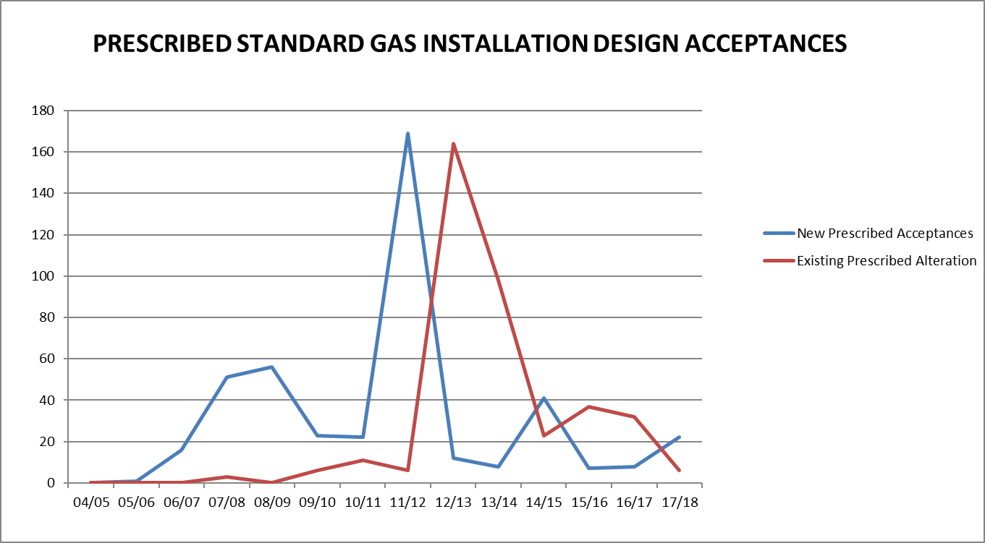

Type B Gas Appliance Acceptance
The Director’s office completed acceptances for 56 Type B gas industrial appliance designs. This is a 20% increase on the previous year. Significant projects continue to impact on the demand for the services of the Director’s office and staff expertise including acceptance and integrity management of the AETV Rolls Royce turbine logic upgrades and Rio Tinto crucible.
Highly visual public displays, the Dark Mofo pyramids, flaming cross and woks, exploiting flame for artistic affect continues to undergo significant review and acceptance. This includes operational management and public safety for these unique type B appliances located, by nature, in close proximity to the public.
Figure 6
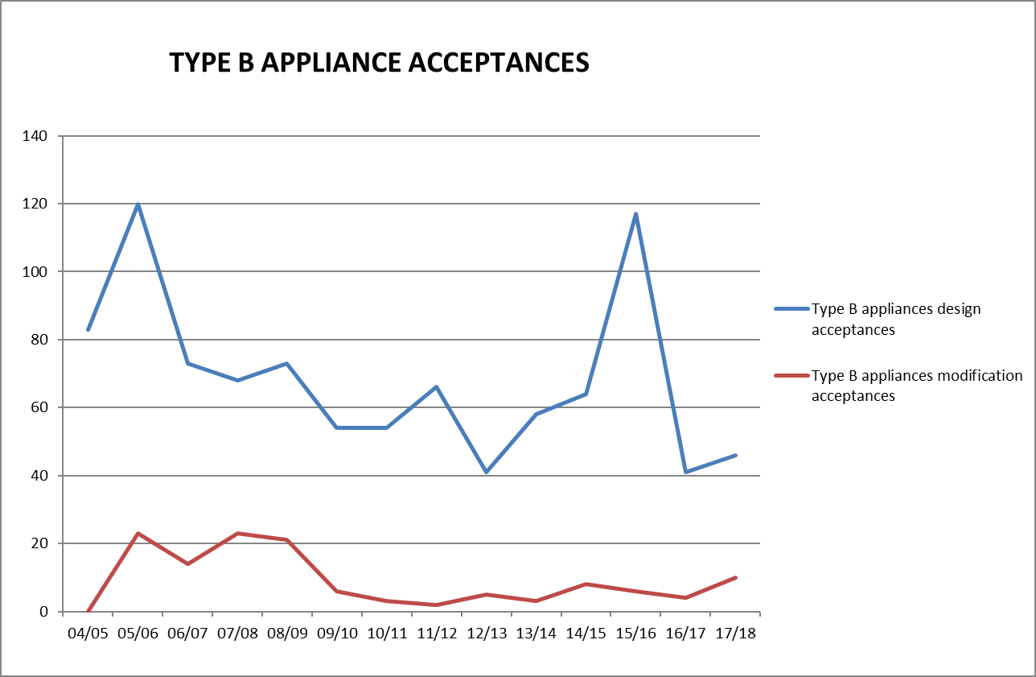
Figure 7
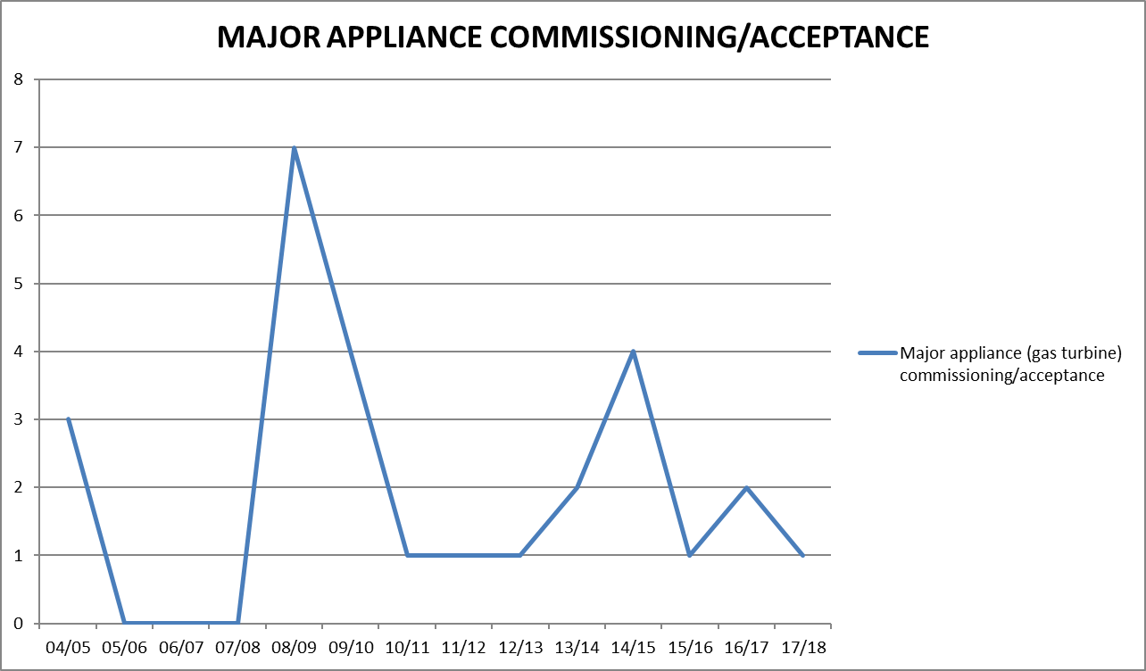
Figure 8
GAS SAFETY MANAGEMENT PLANS

4.5 Type A Gas Appliance Class Certifying External Authorities
There remains five external authorities approved by the Director to certify that Type A gas appliances and components are compliant with standards before being made available for sale in Tasmania. The Director expects to receive and assess a further application from BSI Kitemark, including scheme rules and associated accreditations, for recognition as an external authority.
Energy Safety Victoria (ESV) audited the certifying bodies for the purpose of testing performance against appliance conformance standards. Performance reporting is supplied to each state and the Director accepts the interstate regulator’s audit results.
In conjunction with the Gas Technical Regulators Committee (GTRC), the Director aided development and implemented nationally consistent gas appliance recall guidelines, rules for gas appliance certification bodies and assessment criteria for the recognition of external authorities.
A cost benefit analysis is currently being conducted into increasing safety critical testing for high risk appliances identified through national incident data including BBQs, portable heaters and domestic cooking appliances. The result of this analysis is expected in the latter half of 2018.
The 1st July 2017 saw the implementation of a significant safety initiative by national gas technical regulators; the requirement for all domestic gas cooking appliances manufactured after that date to be fitted with flame safeguards that shut off the gas supply if the flame is extinguished. This project was driven by national incident data which is also compelling jurisdictions to investigate the replacement of the current POL connection between gas cylinders and appliances. The GTRC will continue to consult and work with industry to ensure any such replacement provides measurable public value.

Table 5: Tasmanian approved gas appliance external authorities
Organisation | Address
Australian Gas Association | 66 Malcolm Road, Braeside, VIC 3195
SAI Global | 286 Sussex Street, Sydney, NSW 2000
IAMPO R&T Oceana ‘Gas Mark’ | 1040 Dandenong Road, Carnegie, VIC 3163
Global Mark Pty Ltd | Suite 4.07, 32 Delhi Road, North Ryde, NSW 2113
Vipac Engineers & Scientists Ltd | 279 Normanby Road, Port Melbourne VIC 3207 Australia

4.6 Type A Gas Appliance Acceptance - Individual Appliance Certification Schemes
The Director maintains a policy that single gas appliances imported into Tasmania may undergo individual site safety certification and acceptance. This scheme allows unique new non-certified individual appliances to undergo inspection for safety certification against relevant technical standards determined by the Director. Appliance testing undertaken under the individual appliance scheme is less rigorous than laboratory assessment offered by main stream type testing schemes. Subsequently the scheme must be utilised for genuinely unique gas appliances as opposed to financial gain from importing gas appliances.
The demand for the Tasmanian specific certification scheme decrease significantly to 3 separate appliances approved in 2017/18. Notwithstanding this, the availability of overseas gas appliances through the internet is expected to maintain a demand for individual certification.
The Director remains in discussions with already approved external authority, IAMPO R&T Oceana, who is in the process of developing an individual appliance scheme. If this new scheme is adopted by the Director it is expected to provide increased appliance conformity and system efficiencies whilst providing consumers with greater choice.
Individual appliance mutual recognition arrangements with interstate gas regulators are in place. Legislation enables importation into Tasmania of unique appliances previously approved by other interstate regulators.
Figure 9
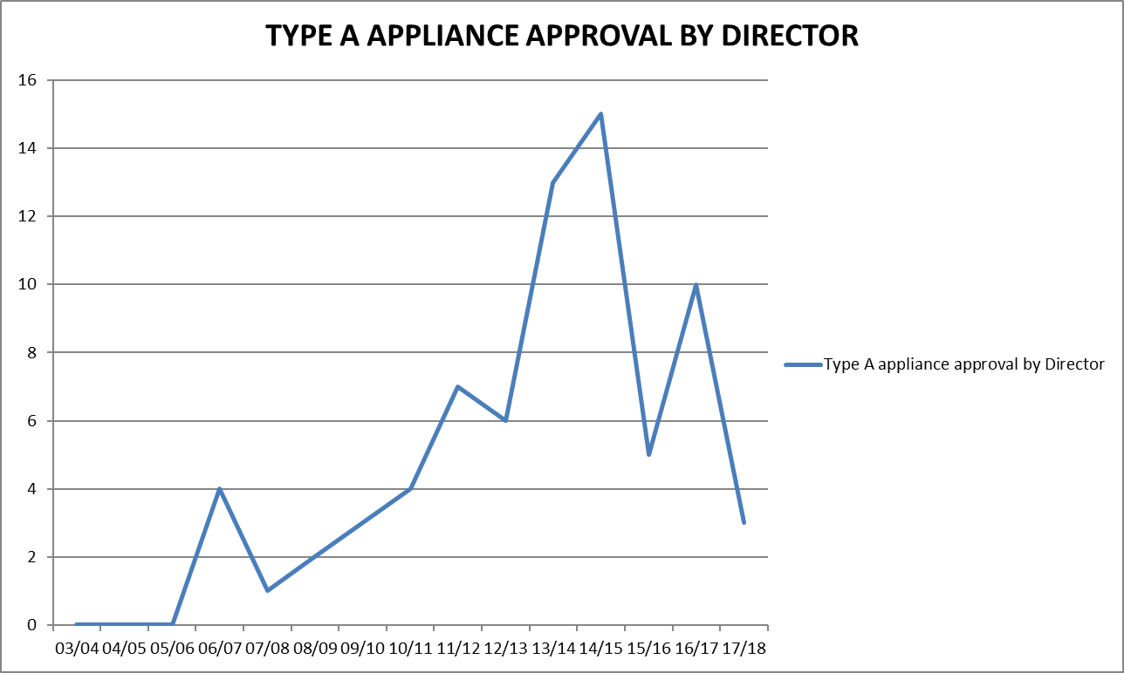

Prohibition of Sale, Product Withdrawal and Recall of Gas Appliances and Components
The Director has responsibilities pursuant to Section 79 A-C for prohibition of supply of unsafe gas appliances.
Due to proactive voluntary recalls and appliance remediation actions taken by gas appliance manufacturers and importers there were no prohibitions issued on the sale of unsafe and non-compliant gas appliances during 2017/18.
However, following safety concerns, the Director’s office assisted and supervised several market initiated recalls and a testing program within Tasmania.
Modern building construction requirements including the lack of ventilation, and particularly where there is a negative pressure environment caused by operating kitchen range hoods or bathroom exhaust fans (or both), has caused concerns nationally with respect to open-flued gas heaters. The combination of a negative pressure environment and a non-compliant appliance significantly increases the risk of fatality or serious injury from carbon monoxide poisoning. In response, the GTRC have required further testing for all appliances of this type. These testing results are expected in the 3rd quarter of 2018 and may result in further action being required.

Table 6: Tasmanian gas appliance and components prohibition of sale, product withdrawal, recall, and safety alert
Appliance | Action | Reason for Action
Amalgamated Hardware Merchants Ltd — Campmaster CM1950 Butane Heater | Voluntary local recall - Removed affected stock from the field. | If the product is not used in accordance with the operating instructions, elevated levels of carbon monoxide may be emitted when the knob is set at a specific position between ON and OFF.
BSH Home Appliances Pty Ltd — Bosch Freestanding Gas/Electric Cooker 60cm | Voluntary local recall - Removed affected stock from the field. Regular retrofit repair updates. | Adaptor between the gas supply and the appliance may crack, causing a potential gas leak. Leaking gas may cause an explosion
Cannon Canterbury and Fitzroy inbuilt space heaters | Inspection and remediation program, Director direct mail out to identified appliance owners, Connections magazine articles | Excessive and unsafe levels of carbon monoxide entering homes under certain climatic and installation conditions
Glen Dimplex - Escea appliances AF700 / AS960 Room Sealed Heater | Removal of affected stock and targeted remedial program | Delayed ignition which results in damage to the inner glass front panel
Kmart Australia Ltd — 'Active & Co' and 'Jackeroo' Portable Single Burner Butane Gas Stoves | Voluntary local recall - Removed affected stock from the field | Gas leakage may occur while the product is in use.  If the defect occurs during use there is a possibility of fire or explosion.
Rinnai Australia Pty Ltd — Rinnai Symmetry Inbuilt Gas Log Effect Space Heater | Voluntary national recall, Connections magazine article, direct mail out to identified appliance owners | Delayed ignition due to low gas pressure causes the mesh-guard to separate from the front of the heater or the glass front to break, posing a risk of injury to the user.
Sitro Group Australia Pty Ltd — Gasmate Butane Heater Model BH10PL | Voluntary national recall, Facebook post | If used indoors on the lowest possible heat, dangerous combustion gas by-products may be produced.
Thetford Australia Pty Ltd - 3-Way Absorption Fridge | Voluntary local recall - Removed affected stock from the field. Regular retrofit repair updates. | If the test point nut is not correctly tightened, it could cause a gas leak, potentially leading to a fire
Vulcan /Pyrox Heritage Heaters | Inspection and remediation program, Director investigation and identification of installed heaters | If the house is well sealed and the heater is operating at the same time as a kitchen or bathroom exhaust fan, carbon monoxide from the heater can be drawn into living areas.

Major Events
Significant resources continue to be deployed to ensure public safety at significant Tasmanian events such as The Taste of Tasmania, Dark Mofo, Agfest, Taste the Harvest and Festivale. GSS also expanded this successful regulatory and safety focus to include smaller boutique events in regional areas during the reporting period. Whilst gas installation compliance and safety is a primary emphasis, GSS also works with event organisers to develop and implement gas safety management plans for the safe use of gas appliances and emergency response in the event of a gas related incident.
The Director’s comprehensive guidance material for both the storage and use of LP gas at public events, and the assessment and use of temporary flame effects operated before an audience, has been well received and implemented by event organisers and display managers, due largely to public exposure risks.
Because of the transient nature of temporary food vendors GSS have implemented a database to encourage regional consistency and ensure compliance instructions provided are followed up on at the next event the vendor attends.

Internet Sale of Gas Appliances
The sale of new, non-certified products imported into Australia and purchased via the internet by consumers continues to be difficult for gas regulators to regulate.
The significant reduction in Australian manufactured appliances, and a transfer to Asian offshore manufacturers, has seen this trend of importation of non-certified products grow considerably.
Wholesaling of gas appliances via internet-based sales sites without appliance certification is creating an unacceptable void in the appliance safety certification scheme and increasing risk to the public.
Importers often move to alternate interstate locations to avoid regulators’ attempts to implement legislative actions. Importers are prepared to undertake significant actions to avoid detection and the administrative powers of regulators.
The Director continues to investigate regulatory options, in consultation with other jurisdictions.

Carbon Monoxide
A carbon monoxide awareness program continues to be a priority of the Director and the program is consistent with the national strategy for exposure to carbon monoxide.
Considering national incident data, portable gas appliances and open flued gas heaters pose the greatest risk of carbon monoxide related incidents. The former mainly as a result of misuse and appliances not being operated in accordance with manufacturer’s instructions; indoors and unventilated locations.
The Director increased public education through distribution of a CO awareness brochure to every Tasmanian household. Other targeted carbon monoxide education programs has seen the Director’s office work with training providers and articles in the Consumer Connections and Worksafe’s Workplace Issues magazines.

Gas Installation and Appliance Incidents
GSS has responded to 16 gas storage, installation and appliance incidents in this reporting period. This is a considerable decrease on the last reporting period (refer figure 10), providing confidence in the Director’s risk based targeted intervention programs.
Portable LP Gas storage and appliance incidents remain the predominant cause resulting in twelve investigations, which contrast with natural gas installations that only accounted for two. Tasmanian statistics are consistent with national trends showing a disproportionate number of incidents involving the use of portable gas storage and appliances compared to other forms of gas installation. With the increase in affordable portable gas appliances this is predicted to represent a major risk to Tasmanian consumers. Again this is compelling national gas safety regulators to investigate the replacement of the current POL connection between gas cylinders and appliances, and the development of additional local and national minimum safety standards including oxygen depletion monitoring devices and tilt sensing interlocks.
The continued collection and maintenance of reliable local and national incident data will allow the Director to identify trends in incident root cause. As a result, this will allow the Director’s office to provide appropriate targeted program strategies along with other gas technical regulators, educational providers, certification bodies, manufacturers, suppliers and maintenance contractors.
Figure 10

SECTION 5: Office of the Director of Gas Safety Programs/Achievements
The Director has accomplished all reactive programs and is nearing completion of the Gas Safety Legislation restructuring including the development of valuable and accountable regulatory models to meet public safety expectations.
The following programs are mandated under the Gas Act 2000 and the Gas Pipeline Act 2000.

Regional Delivery of Programs

Table 7: Operation and maintenance of administrative systems primary outputs
Industry Segment | Business Management System | Output | Reason
Management | Annual report output and statistical collation | Annual report on activities of the Director | Legislative requirement Gas Act 2000
 | Time allocation data collation for gas entity activity | Time records | Recovery of reasonable cost pursuant to Gas Act 2000
 | Communicate with national gas regulators | Maintenance of technical and evolving standards | Safe gas installations and appliances
 | Policy development | Monitoring, review and improvement of legislation and prescribed standards | Maintain contemporary regulation in an ever evolving industry
 | Investigation documentation | Review and update investigation pro formas and guidance | Bring into line with CBOS expectations and policy
Business administration and appliance programs | Business document control | Administer the document and publications register | Maintenance of document and publications standards
 | Web development and management | Review and update the gas website | Quality control of public documents
 | Communications management system | Internal delivery of relevant and timely publications | Identify safety, training and educational needs and stakeholder expectations
 | Gas appliance (Type A) safety management | Identify and implement unsafe gas appliance notifications | Consumer safety
 | Gas appliance approval (Type A) program | Conduct safety approval procedures for appliances and establish national alliances | Consumer safety
 | Gas External Authority approval | Ensure competent organisations are approved to examine gas appliance safety | Consumer safety
 | Accident and incident investigation program | Respond to accidents and incidents on gas transmission, distribution and installations that pose a risk to supply and public safety. | Community safety  Gas emergency response
 | Undertake commercial sensitivity assessment of gas infrastructure information records | Deliver timely Freedom of Information requests | Preserve information confidentiality
 | Gas safety management plan (GSMP) acceptances | Ensure adequate GSMP for large or high risk installations | Safety and reliability of installations
Gasfitter administration | Gasfitter installations notification database | Gasfitter certification data | Verify gasfitter certifications of gas installations
 | Gas installations Acceptance program | Deliver 3 regional installation technical compliance programs | Consumer safety
 | Gas appliance design and installation acceptance (Type B) | Deliver 3 regional Type B appliance technical compliance programs | Consumer safety
 | Gasfitter education and management of CPD opportunities | Deliver targeted training and accept external CPD training | Legislative requirement Occupational Licensing Act 200, Consumer Safety
 | Gasfitter Licence applications | Verify and endorse gasfitter licence applications | Legislative requirement Occupational Licensing Act 200, Consumer Safety
Gas Distribution | Gas Entity network approval program | Review proposed network submissions | Ensure construction standards compliance
 | Gas Entity network integrity monitoring | Review of safety and operating plans | Ensure acceptable levels of public risk and supply integrity
 | Installation disconnections and reconnection procedures. | Deliver timely disconnection orders | Control unsafe or non-compliant gas installations
Gas Storage and Conditioning | Gas Storage Systems | Design acceptance and supplier / stakeholder management project | Target supplier compliance in existing and new gas storage products
 | Gas Storage Systems safety management and emergency response planning | Approval of GSMP | Consumer and public safety enhancement

Targeted recruitment resulted in the filling of a new Standard Gas Installation inspectors positions. This has provided much needed support to meet the expectations and safety outcomes of industry and the public. It has allowed proactive inspections of standard gas installations, which has substantially, reduce the regulatory and public risk posed by historical constraints.

Table 8: Summary of Achievements
Activity | Function | Safety Outcome
Gas Distribution and Storage
Regulated the safe and compliant repair of high pressure steel pipeline in Derwent Park Road | Ongoing pipeline integrity and public safety | Reduce levels of public risk and enhance reliability
Review network technical design including approval of independent design certification | Ensure ongoing contemporary, safe and compliant system design | Maintain infrastructure safety and control public risk
Contribute to the development of appropriate safety standards | Contributing members of Australian standards committees for gas networks, and gas storage | Protection of public through contemporary compliance standards
Tasmanian gas supply emergency management including development of network gas quality excursion protocols | Tasmanian Jurisdictional Contact Officers under national (NGERAC) planning frameworks. Stakeholder engagement and development of stakeholder obligations | Enhance Tasmanian natural gas supply emergency planning
Investigated uncontrolled gas release incidents on gas infrastructure including successful prosecution for excavating in the vicinity of gas infrastructure without permission | Identify causation of incidents, review operational standards and instigate regulatory actions | Prevent recurrence of uncontrolled gas incidents, and ensure acceptable levels of public risk
Reviewed network reliability, integrity, operational management, public safety and condition survey | Ensure compliance, adequacy, currency, accuracy and reliability of operational records | Maintain supply safety and control public risk
Reviewed development of gas entity operations safety and operating plans | Ensure compliance and adequate management of gas infrastructure through documented policies and procedures | Maintain supply safety and control public risk
Compliance audit program for LNG gas pipeline facilities | Ensure compliance of emergency response and planning | Maintain infrastructure safety and control public risk
Gasfitter Licensing and Gas Worker Accreditation
Collaboration with stakeholders to identify required training and skills development for CPD | Ensure that comprehensive standards for training | Ensure that competent persons undertake all forms of gas fitting work
Developed and delivered targeted training to wider gas fitting industry | Maintain gas fitter competency around topical technical issues | Ensure gas installation compliance and standards providing adequate level of consumer safety
Investigated non-compliant gas installation work standards and resultant safety issues | Issue gasfitter defects, infringement, consumer disconnect and rectification notices | Ensure gas installation safety standards for consumers
Provided advice and conducted investigations | Ensure compliant gas fitting and licensing standards | Ensure safe gas fitting and licensing standards
Gas Appliances and Installations
Contribute into development of suitable electronic system to support the operations of the licensing and technical CBOS outputs | Provide and maintain a single, central system to provide sufficient data to implement a risk based inspection program. | Protection of public by developing inspections through risk-based assessment of gas fitters based on their experience and history of recorded defects
Contribute to the development of appropriate safety standards | Contributing members of Australian standards committees for type b appliances | Protection of public through contemporary compliance standards
Investigated uncontrolled gas incidents on in situ and portable gas appliances | Identify causation of incidents and review technical standards | Prevent reoccurrence, produce education materials, web information and implement product withdrawal standards
Collaborated with national gas technical regulators on gas appliance safety concerns and initiate actions in respect to appliance certification bodies, suppliers and consumers | Minimise the likelihood of death or injury from exposure to unsafe gas appliances | Protection of consumers
Implementation of policy for gas installations at public events | Minimise the likelihood of inadequate installation and design | Ensure a transparent safety model is implemented for consumers and the public
Implemented carbon monoxide education program | Minimise the likelihood of death or injury from exposure to carbon monoxide | Prevent reoccurrence and provide education
Continued to research, review and adopt relevant technical standards and codes for gas appliances | Develop, in conjunction with GTRC, appliance certification scheme rules | Ensure a consistent and robust national appliance certification scheme that effectively delivers safety outcomes for ever increasing imported products
Continued to develop and implement gas safety management planning for LNG, CNG, Bio Gas Storage | Ensure gas storage systems installations achieve acceptable levels of risk control and emergency preparedness | Manage consequences and inherent risks
Continued to develop and implement gas safety management planning for flare and waste gas removal systems | Ensure installations achieve acceptable levels of risk control and emergency preparedness | Manage specialised surveying services to contain inherent risks
Gas Technical Standards and Working Groups
Engaged gas supply industry stakeholders following out of specification gas incident | Develop industry procedures and communication protocols in the event of reoccurrence | Ensure safe and reliable supply of natural gas to vulnerable consumers
Participated in development of industrial appliance safety standards | Ensure evolving type A and B appliance design achieve acceptable levels of risk control | Set contemporary appliance design specifications
Stakeholder Relations
Facilitated stakeholder meetings for the management of buried infrastructure | Development of safe work procedures for work adjacent to buried infrastructure | Ensure worker safety, recording and quality of location information
Continued to facilitate gas entity meetings for the management of safe gas infrastructure | Maintain adequacy of management communications | Ensure safety and reliability of Tasmanian NG supplies
Contributed to national Gas Technical Regulator Committee programs | Harmonise gas product and legislative outcomes to national and COAG standards. | Maximise safety and economic outcomes to gas consumers
Committed to GTRC audit program for external authorities. | Provide verification of external authority outcomes | Ensure consumer safety and quality of approved gas appliance on the Tasmania market
Communications and Education Management
Provided industry specific training presentations | Provide targeted guidance in respect to ground works adjacent to buried gas infrastructure, and gas fitting work standards | Manage public risk by ensuring relevant industry stakeholders are aware of their obligations and safety expectations
Administered a gas specific internet site and gas safety publications | Facilitate stakeholder and consumer access to gas technical standards and safety information | Provide timely delivery of industry communications products
Contributed articles to Connections trade and consumer magazines | Improve stakeholder and end user education on gas safety | Enhance gas education policy and expand audience
Issued Guidance Notes following investigations | Provide stakeholder advice | Enhance safety of civil and gas workers
Business Administration
Administered, reviewed and identified opportunity for business management improvement | Continue development of risk based business unit models | Efficiently administer all business processes
Review of document standards for web viewing | Improve industry efficiencies | Enhance timely delivery of services
Continued targeted recruitment | Ensure adequacy of regional safety and technical coverage thus improving output in line with industry and community expectations | Ensure acceptable staff workloads and enhance timely delivery of services
Policy Development
Review of Act and Regulations | Ensure adequate and improved regulatory requirements to facilitate safe outcomes in an evolving industry | Provide consistent and contemporary gas safety framework

Inspection Program
Demand for Gas Standards and Safety’s complex, prescribed standard gas installation and type B appliance inspection remained stable this reporting year. To ensure appropriate management of resources, the Director’s office examines the inherent risk of individual installations and appliances to enhance field-based inspection programs. This resulted in increased onsite inspections of installation safety and compliances as opposed to desktop design assessments (refer figures 11 and 12)
Due to the Director’s belief that standard gas installations and portable appliances are the greatest organisational risk confronting this office, GSS continued to intensify its proactive regional ‘standard’ gas installation inspection schedule. Targeted recruitment also provided a dedicated state wide role for the management of standard gas installations, substantially reducing the regulatory and public risk posed by historical constraints.
Figure 11

Figure 12

Technical Standards Development
Development of safety and technical standards for the Tasmanian gas industry is undertaken to meet emerging trends and technology advancements. Consultation between industry stakeholders, end users, interstate regulators and gas industry organisations is ongoing to ensure currency, relevance and completeness of Tasmanian gas standards.
The Director’s office routinely provides technical comment and feedback to Australian Standards committees in respect to proposed amendments and drafts (refer Table 9).
The Director is also represented by GSS on Australian Standards committees AS 3814 Industrial gas appliances (AG-001-00-05), AS 1596 The storage and handling of LP Gas (ME-15) and AS/NZS 4645 Gas distribution networks (AG-008). Considerable resources have been allocated to a number of these committee roles, providing input into evolving industry standards as they are amended to manage ongoing appliance, gas storage and gas infrastructure technological and knowledge advances – including in particular NG gas odorant management, reinforcement of pipeline squeeze offs and safe development zones adjacent to gas distribution infrastructure.

Table 9: Technical Standards Development and Implementation 2017/18
Standard | Title | Revisions
AS 1596 | The storage and handling of LP Gas | Ongoing input to Standards committee ME15 agenda items including development of standard appendices covering odorant management through the supply chain and guidance for authorities, drivers, LPG industry business managers and supervisors for tanker operation.
AS 3814 | Industrial and Commercial Gas Appliances | Ongoing input to Standards committee AG-011 agenda items including development of provisions for complex turbine machinery and appliance installation risk control
AS/NZS 4645 | Gas distribution network management (parts 1, 2 & 3) | Ongoing input to Standards committee AG-011 agenda items including allowable energy release rates, reinforcement of squeeze off points, odorant management and leakage detection.
AS 5263 | Gas appliances  (part 10) | Amendments aimed at providing additional direct-fired air heater safety and performance assurances for manufacturers, designers, regulatory authorities, testing laboratories and similar organisations.
AS/NZS 2885 | Pipelines—Gas and liquid petroleum (parts 0, 1 & 6) | Clarification of definitions, scope and safety management processes

Vehicle Gas Fitting and Stationary Engines
While the vehicle gasfitter worker competency training package for LNG, CNG and LP gas vehicle gasfitters by TasTafe and the worker licensing scheme by CBOS are operating effectively, the slowdown of commercial uptake of gas as an automotive fuel has again slowed.
On the other hand, the Director continues to accept accepted stationary reciprocating and rotating engines for the generation of electricity, both as an emergency backup and primary generation. In the current energy climate the Director expects this trend to continue.
No new work was undertaken by the Director’s office in respect to the technical compliance for the vehicle gas fitting industry including automotive gas fitting work notifications. Further development in this area is reliant on the implementation of the Gas Safety Bill 2017.

Gas Committees and Associations
The Director remained actively involved as a member of the GTRC. Membership of this national committee provides Tasmania with current gas appliance and gas technical and safety information exchange, including products withdrawn from market, illegal sales of equipment, and audit results by interstate regulators on appliance certifying bodies. GTRC member communications frequently result in product warnings to the Tasmanian public, gasfitter communications and appliance safety investigations.
In addition to reactive state based gas supply coordination role, the Director is also the Tasmanian Jurisdictional Contact Officer (JCO) for the purposes of the National Gas Emergency Response Advisory Committee (NGERAC). This permitted the Director’s office to participate in a valuable national energy curtailment emergency exercise that highlighted energy interrelationships due to gas fired electricity generation.

Table 10: Participation in committees and organisations
Committee | Member organisations | Committee purpose
Gas Technical Regulators Committee (GTRC) | All Australian States and New Zealand gas technical regulators | Harmonisation of national gas safety standards.  Industry communications.  Acceptance of external authority performance audit.
National Gas Emergency Response Advisory Committee (NGERAC) | Federal jurisdictions, Gas infrastructure owners,  GSS, Department of State Growth | Facilitate efficient and effective communication across industry and government during major national natural gas supply shortages.
Australian Standards Committees | Numerous | Provide Tasmanian input into evolving issues and continual improvement of technical standards for public and infrastructure protection.
POL Working Committee | Australian States and New Zealand gas technical regulators and LP Gas industry stakeholders | Investigate the replacement of the current LP gas cylinder valve to appliance connection for something safer
Tasmanian Gas Fitter Competency Standards Committee | GSS, TasTAFE and occupational Licensing | Ensure adequate and appropriate learning outcomes for gas fitters

Policy Development and Legislation
Significant resources have been required to undertake a major review of both the Gas Pipelines Act 2000 and the Gas Act 2000. The purpose of the review being to separate the economic/licensing functions administered by the Department of State Growth and the technical/safety functions administered by the Director of Gas Safety and Department of Justice. These functions are currently combined in both sets of legislation and in many cases are not clear.
The Gas Safety Bill and Gas Supply Industry Bill need to be considered together with regard to development, introduction and proclamation timeframes. Both are now essentially complete, including extensive stakeholder consultation, and in line with the most recent legislation priority certificates are due for introduction to Parliament (first reading) the week commencing 10 September 2018.
Resources were also required for amendments to the Occupational Licensing (Gas-fitting Exemption) Order under the Occupational Licensing Act 2005 (OLA). This provided a limited exemption to allow gas entity officers to perform certain gas-fitting work associated with gas infrastructure operations.
  - Communications and Gas Safety Education
Development of educational information to inform stakeholders of legislative and technical matters has remained a focus during 2017/18. See Table 11 for outputs of this program.
A new CBOS Consumer Connections magazine that broadened public safety message penetration complemented the bi-annual Connections magazine distributed to allied trades.
Also well received was a presentation to over 130 gasfitters concerning technical and compliance issues identified during inspections including location of LP gas cylinders, mobile catering installations and fire resistant materials. These presentations were followed by an open forum that allowed the industry to ask questions of the Regulator. Based on the positive outcomes and feedback from this forums the Director intends to conduct further industry events. These upcoming presentations will also provide industry with constructive and valid CPD points under the Occupational Licensing Act 2005.

Table 11: Communication products
Program | New or Managed Output 2017/18 | Target Audience
GSS website | Updated gas safety and technical standards website | Gas consumers  Gasfitters  Gas workers  Gas distributors  Community  Rural landowners  Infrastructure owners
Connections magazine | Current gas consumer safety and technical gas topics | Gas consumers  Gasfitters
Presentations | Gas fitting standards and open forum | Gasfitters
 | Gas Safety and role of GSS | TasTafe gas fitting classes
Gas safety and technical publications | Carbon Monoxide publications including awareness brochure distributed to every Tasmanian Household | Gasfitters  Consumers  Community
 | Pipeline planning corridor guidance and information sheet | Planning Authorities  Landowners  Developers
 | Information Sheet – Storage of LPG at public events | Gasfitters  Installation owners  Installation designers
Expos and other public events | AGFEST and HIA Home and Building Expo | Gas consumers  Gasfitters  Gas workers  Community  Rural landowners  Civil Contractors  RV industry
Social media (Facebook) | Provide gas appliance safety and recall information and links to public and industry | Gasfitters  Consumers

Staff Development
Continuous development is encouraged for all authorised officers and administration staff. Staff development and mentoring is ongoing with additional staff training requirements identified in Table 12.
Staff training is provided in accordance with agreed development plans that provide and develop individuals’ and Gas Standards and Safety’s growing areas of speciality. Staffing, training and operational efficiencies are priorities so core training is provided to allow regional programs including Type B gas appliance, design assessment, combustion engineering and product monitoring.
Technical library resources also continue to be sourced to ensure Gas Standards and Safety staff capability for meeting the expected gas industry emerging technology, energy efficiency, fire hazard analysis and risk analysis.

Table 12: Staff development
Issue or Risk | Development
Governance | Regulatory compliance process
Rotating appliances | Combustion engineering standards
Permitting fuel cells (hydrogen) | Certification and building standards
Reciprocating engines including automotive gas installations | Internal combustion engine safety
Technology and specialist control equipment | Equipment fit for purpose analysis and incident investigation. Original equipment manufacturer programing access certificates.
High pressure gas infrastructure fabrication and quality assurance standards | Model to compliment layers of protection philosophy
LNG technical and safety standards | Quantitative risk assessment and layers of protection philosophy for safety of LNG consuming installations
Gas storage | Liquid storage and gas vaporisation
Gas measurement | Liquid and gas chromatography, mass measurement and meter proving
Waste and biogases | Waste gas quality and safe combustion
Pipeline continuity of supply and public risks | Pipeline direct assessment and validation procedures  Steel pipeline corrosion control cathodic protection
Fire science, fire dynamics and fire causation | Fire investigation, key technical skills interpreting the patterns and phases of fire
Highly technical incident investigations including relationships between causation and operational management | Precise analysis of incident root cause/s
Health and Wellbeing | Mental Health First Aid

Gas Supply Management
As reported previously the Director is assigned the role of Tasmanian Jurisdictional Contact Officer (JCO) under the National Gas Emergency Response Advisory Committee (NGERAC). Meetings of the Natural Gas Supply Emergency Coordination Committee were not convened by the Department of State Growth during this reporting period. This has required the Director to further resource the coordination and response to supply emergencies for the purpose of advising the Minister on how to respond to natural gas supply situations.
A staff availability roster is operational for after-hour response to onshore gas infrastructure and installation incidents, as well as intrastate, interstate and offshore supply or gas quality issues.
There were no gas specification incidents during the reporting period however, industrial action and gas production plant breakdowns had industry on high alert on three occasions. These threats to gas supply provided valuable learning opportunities with respect to communication protocols between the Department of State Growth, Australian Energy Market Operator (AEMO), NGERAC and the Director. This exchange enhances preparedness for industry communication and response protocols and the Director’s office emergency callout to incidents during after-hours response.
Involvement during summer in 7-day outlook summaries and a combined National Electricity Market Emergency Management Forum (NEMEMF) and NGERAC emergency exercise further enhanced the Directors preparedness for gas supply shortfall incidents. The emergency exercise provided the opportunity to consider responses and interoperability processes when managing major electricity and gas supply shortfalls.

Emergency Incident Coordination
The Director maintains management plans and internal procedures for GSS ‘on shore’ emergency gas incident response protocols. Emergency Incident Response Management plans and the staff availability roster have operated successfully to cater for an expanding use of different fuel gases and complexity in gas supply chain management. As a result the Director of Gas Safety’s incident response management system continues to enhance enforcement of real time isolation of uncontrolled gas escapes
Response to 35 installation and supply incidents during the reporting period and total of 309 over ten years of implementation has been beneficial to Tasmania Fire Service and Tasmania Police in responding to incidents and ensuring safe procedures for gas isolation and recovery.

SECTION 6: Inter-government Industry Administration
Collaboration with the Office of the Economic Regulator ensured a smooth path for pipeline approvals, licensing and recovery of the Director’s reasonable costs from licensed gas entities.
Cooperation with the Tasmania Fire Service and Department of State Growth in relation to fuel gas industry expansion and emergency management guarantees sound intergovernmental communications, increased response capability and thorough incident investigation, which provides a consistent and harmonised response from government.

SECTION 7: Conclusion
Gas transmission programs pursuant to the Gas Pipelines Act 2000 have also required substantial resourcing including oversight of pipeline integrity studies including safety management system, safety and operating plan, cathodic protection and coating surveys.
Reinstatement of the GSS unit staffing levels has allowed targeted intervention programs in line with the identified growth areas; this is required to ensure public value, accountability, efficiencies and effectiveness expected by stakeholders as the Tasmanian gas industry continues to grow.
This has also allowed the introduction of a greater enforcement focus, in particular those matters involving interference with gas infrastructure, diversion and abstraction of gas, gasfitter work standards, focus to standard gas installations, pipeline integrity, gas conditioning, gas storage and new compliance standards.

Dale Webster
DIRECTOR of GAS SAFETY

APPENDIX 1: Glossary and Abbreviations

CBOS | Consumer, Building and Occupational Services
CNG | Compressed Natural Gas
COAG | Council of Australian Government
Director | Director of Gas Safety
GSMP | Gas Safety Management Plan
GSS | Gas Standards and Safety (Unit of CBOS)
GTRC | Gas Technical Regulators Committee
JCO | Jurisdictional Contact Officer
kPa | Kilo Pascals
LNG | Liquefied Natural Gas
LP Gas | Liquefied Petroleum Gas
MAOP | Maximum Allowable Operating Pressure
NEMEMF | National Electricity Market Emergency Management Forum
NGERAC | National Gas Emergency Response Advisory Committee
NG | Natural Gas
PIG | Pipeline Integrity Gauge
TGN | Tas Gas Networks
TGP | Tasmanian Gas Pipeline

